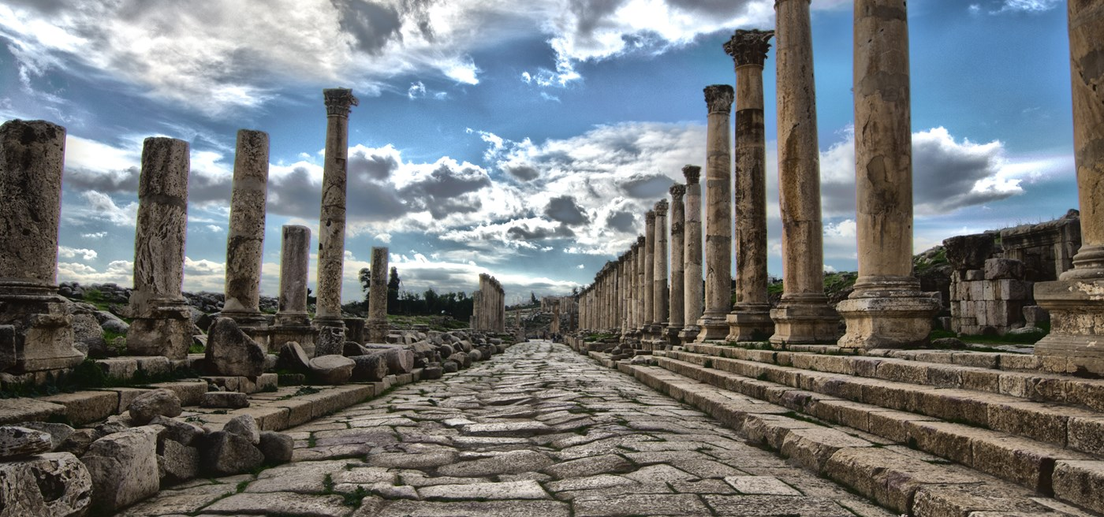
World History Time Periods and Concepts

Period 1: Technological and Environmental Transformations, to c. 600 B.C.E.
- Key Concept 1.1. Big Geography and the Peopling of the Earth
- Key Concept 1.2. The Neolithic Revolution and Early Agricultural Societies
- Key Concept 1.3. The Development and Interactions of Early Agricultural, Pastoral, and Urban Societies

Period 2: Organization and Reorganization of Human Societies, c. 600 B.C.E. to c. 600 C.E.
- Key Concept 2.1. The Development and Codification of Religious and Cultural Traditions
- Key Concept 2.2. The Development of States and Empires
- Key Concept 2.3. Emergence of Interregional Networks of Communication and Exchange

Period 3: Regional and Interregional Interactions, c. 600 C.E. to c. 1450
- Key Concept 3.1. Expansion and Intensification of Communication and Exchange Networks
- Key Concept 3.2. Continuity and Innovation of State Forms and Their Interactions
- Key Concept 3.3. Increased Economic Productive Capacity and Its Consequences

Period 4: Global Interactions, c. 1450 to c. 1750
- Key Concept 4.1. Globalizing Networks of Communication and Exchange
- Key Concept 4.2. New Forms of Social Organization and Modes of Production
- Key Concept 4.3. State Consolidation and Imperial Expansion

Period 5: Industrialization and Global Integration, c. 1750 to c. 1900
- Key Concept 5.1. Industrialization and Global Capitalism
- Key Concept 5.2. Imperialism and Nation-State Formation
- Key Concept 5.3. Nationalism, Revolution, and Reform
- Key Concept 5.4. Global Migration

Period 6: Accelerating Global Change and Realignments, c. 1900 to the Present
- Key Concept 6.1 Science and the Environment
- Key Concept 6.2 Global Conflicts and Their Consequences
- Key Concept 6.3 New Conceptualizations of Global Economy, Society, and Culture

