The Haitian Revolution
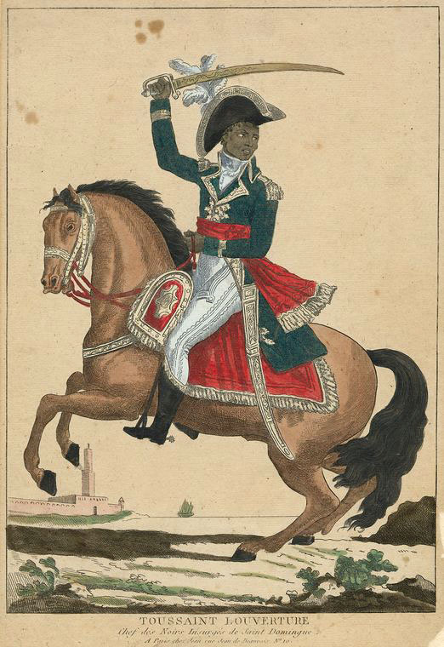
St. Domingue-

Cash crop of

Conditions:

Racial Hierarchy
The slaves received the whip with more certainty and regularity than they received their food.. Mutilations were common, limbs, ears and sometimes private parts…Their masters poured burning wax on their arms and hands and shoulders.. emptied boiling sugar cane over their heads. Burned them alive, roasted them on slow fires, filled them with the gunpowder, and blew them up with a match…”-C.L.R. James The Black Jacobins

- Why would the slaves be treated so harshly?

- Do you think many slaves would withstand this torture?

- What do you predict will happen?
Choose where each class goes:

Black Slaves: 87% of the population

Grand Blancs: 2% of the population (white slave owners)

and

Petit Blancs: 6% of population (artisans, merchants, craftsmen, slave supervisors)
(30,000 total)

Gens de Couler- 5% of the population (free blacks, mulattoes- Multiracial) (24, 000 total)

