Name: Date:
Global History 9H Mr. Lipari

The Warring States Period

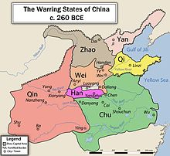
The Warring States Period (481-221 BCE) occurred during the dying days of the Zhou dynasty, when nine different states vied for power and dominion over all ancient China: Shu, Qin, Chu, Han, Lu, Song, Qi, Zhao, and Wu. The Zhou had gradually lost control over these various families and now they were poised to start interminable warfare. Military technology advanced quickly to match the needs of the nine states. Previous wars had seen aristocrats on chariots fighting on open battlefields. But with the increased usage of iron metallurgy, many foot soldiers could be armed with superior iron weaponry (swords, spears, armor, etc.). With larger and larger armies came larger and larger casualties in battle. Administration of the various states increased in complexity, to cope with the needs of armies and taxation, creating sizable bureaucracies dwarfing previous government systems.
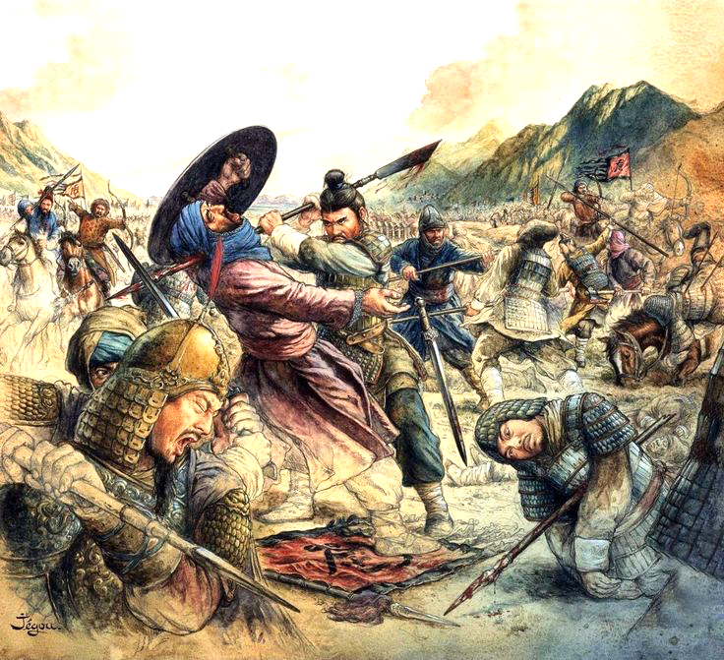
Endless campaigns and battles whittled down the nine competitors to three major contenders over several centuries. They were the Qin, Wei, and the Qi. Eventually, the Qin, a once backwards and half-barbarian state on the borderlands of China, would emerge victorious and unite China.
One of its noblemen, Shang Yang (390-338 BCE), imposed a brutal regime upon his people, but also created reforms that led to the Qin's ascent. He developed a meritocracy for his elites, based upon military skill, while also creating a system of paranoia that assured his people would remain loyal to him and weed out any disloyalty (all crimes were severely punished, while those who failed to report crimes would be cut in half). Additionally, Yang reduced the role of merchants (he considered them parasites), and forced the entire population to "produce or die" in their fields, using proper farming methods. Forced labor was also imposed upon the peasants and slaves. Crime virtually ceased, but the state of Qin was a miserable place to live in. These much-hated reforms allowed for stability in the Qin homelands and eventually for their conquest of China. Ironically, Yang would be executed when a new leader of the Qin, King Huiwen, inherited the throne; Yang fled, but none would hide him from the king, as he had no permit proving who he was, a law Yang himself had established.
During this time, in midst of seemingly endless conflict, numerous philosophers and politicians would attempt to find solutions to achieve peace and prosperity for China. We will learn about three of these schools of thought today and next class.

QUESTIONS

1) Judging from the map, which faction do you think would be most likely to win? Why? What factors would you consider?

2) What military technology allowed for increased size of armies? Why did administrative system change?

3) What two reforms of Shang Yang do you think were the most important? Why?

4) Do you think the brutal reforms of Yang were justified at the time?

5) What were these various states fighting for? Is it a worthy goal?

