Document 1 | Desmond Stewart and the Editors of Time-Life Books, Great Ages of Man: Early Islam, Time-life Books, 1967.

By the middle of the sixth century...Mecca was...prosperous and important. First, it was at the crossroads of the lucrative caravan trade. Vast camel trains, bearing spices, perfumes, precious metals, ivory and silk, filed through the town, headed north on the way from Yemen...to the markets of Syria, and headed east from the Red Sea across the desert to Iraq. Adding to the profits from caravans was a brisk pilgrimage trade, for Mecca was the site of Arabia’s holiest pagan shrine [Ka’ba].
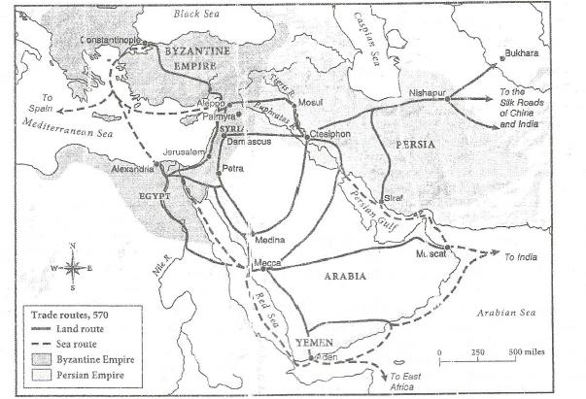

Question 1: What year is shown on this map? How does this relate to the history of Islam and when it was founded?

Question 2: Name three cities that were easy to reach by trade routes from Mecca?

