The Pax Romana

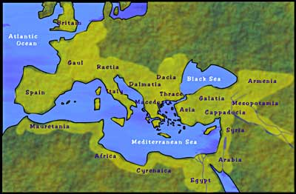
Historians commonly call the 200 years from Augustus onward (27 BCE-180 CE) as the Pax Romana, or Roman Peace. During this time, many cities in the Mediterranean did not bother to maintain or build their walls. This peace was held up by the Roman army, roughly half a million men, perhaps 1% of the total population of the whole empire. The army occupied itself with building the road system of 50,000 thousand miles which connected and integrated every part of the empire together.

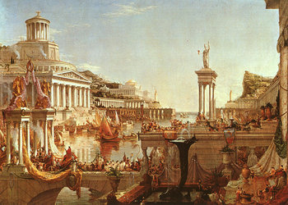
The Mediterranean Sea was cleared of pirates to become a marine highway dotted with seaside villas [mansions], a situation that Europe would not see again for nearly 2,000 years. Land communications were better across Europe and western Asia under the Romans than at any other time until the invention of the train engine. Lighthouses guided ships along the coast of the Mediterranean. With Rome's peace, and its relatively light taxation, came prosperity. As city ruins show, some desert regions of north Africa and western Asia enjoyed a level of wealth under Roman rule that has yet to be repeated, while cities in Europe would have to wait another 1,000 years to see such prosperity.

The Romans, like most polytheists, were religiously tolerant. The many belief systems of the empire were not suppressed but regulated; if there were offerings for the emperor at religious rituals, people had freedom to worship. While the Romans suppressed several belief systems such as Judaism, and Christianity at times during the Pax Romana, both these groups either rebelled against Roman rule or were viewed as disloyal by Rome. Slavery, the bedrock of the Roman economy, also flourished however. But it must be said that slavery at the time was not race-based and conditions depended on the slaves' occupation, and many slaves could purchase their freedom. Trade exploded and a highly complex economy developed around the Mediterranean Sea, with the Romans as the main recipient of this wealth. A Roman citizen could walk from one end of the empire to the other and speak Latin to his/her fellow citizens, while seeing 100 cities that all had baths, amphitheaters, roads, forums [markets], and a grid pattern.

The Pax Romana was a time of prosperity for much of Europe, but it would not last forever.

