Document 4: Trade and the Spread of Islam in Africa
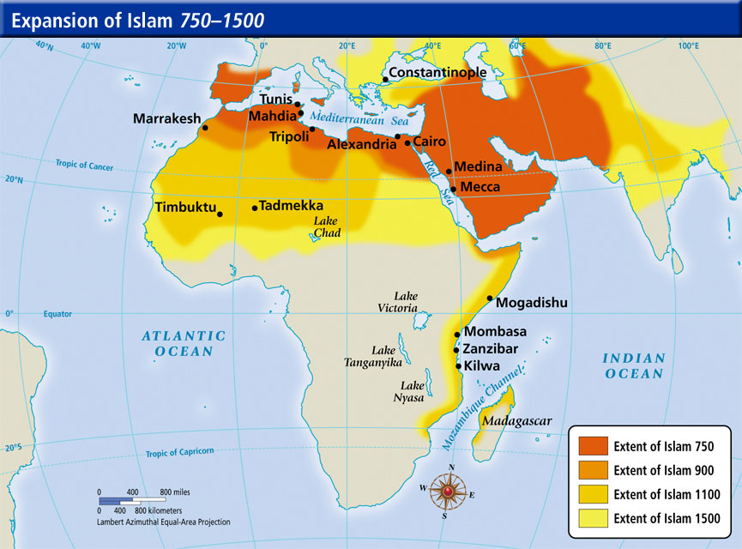
Multiple Trajectories of Islam in Africa
Islam had already spread into northern Africa by the mid-seventh century CE, only a few decades after the prophet Muhammad moved with his followers from Mecca to Medina on the neighboring Arabian Peninsula (622 CE). The Arab conquest of Spain and the push of Arab armies as far as the Indus River culminated in an empire that stretched over three continents, a mere hundred years after the Prophet’s death. Between the eighth and ninth centuries, Arab traders and travelers, then African clerics, began to spread the religion along the eastern coast of Africa and to the western and central Sudan (literally, “Land of Black people”), stimulating the development of urban communities. Given its negotiated, practical approach to different cultural situations, it is perhaps more appropriate to consider Islam in Africa in terms of its multiple histories rather then as a unified movement.
The first converts were the Sudanese merchants, followed by a few rulers and courtiers (Ghana in the eleventh century and Mali in the thirteenth century). The masses of rural peasants, however, remained little touched. In the eleventh century, the Almoravid intervention, led by a group of nomads who were strict observers of Islamic law, gave the conversion process a new momentum in the Ghana empire and beyond. The spread of Islam throughout the African continent was neither simultaneous nor uniform, but followed a gradual and adaptive path. However, the only written documents at our disposal for the period under consideration derive from Arab sources (see, for instance, accounts by geographers al-Bakri and Ibn Battuta).

Department of the Arts of Africa, Oceania, and the Americas. “Trade and the Spread of Islam in Africa.” In Heilbrunn Timeline of Art History. New York: The Metropolitan Museum of Art, 2000–. http://www.metmuseum.org/toah/hd/tsis/hd_tsis.htm (October 2001) [Edited]
QUESTIONS
- Who first began the conversion of Africa to Islam? Who were the first converts?

- How long did it take to convert most of North Africa? How was this accomplished?

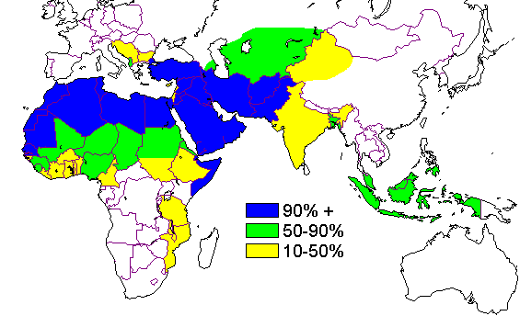
Document 5: Spread of Islam 632 CE-2000 CE

Beginning in the 7th century CE, Muslim merchants from India, Persia, and South Arabia often came to Southeast Asian harbors. Eventually, they settled in larger numbers, bringing along with them their own “religious experts, or “mullahs” (Houben 153). They also built prayer houses and religious buildings in their towns. When a local ruler converted to Islam as a result of these Muslim traders’ inhabitance of the harbors, he could “command a new, more universal kind of legitimacy that transcended his own group and therefore allowed for the rise of greater policies” (Houben 153). In other words, because he converted to Islam and became a religious ruler, he had a new kind of authority. An important point in Islam is legitimacy through the power of God. When this local ruler converted to Islam, he became more powerful because of his self-proclaimed legitimacy via the power of God. Because of these traders’ practice of Islam in their towns and subsequent influence on the locals, Islam was spread to Indonesia starting with seaside ports and harbors. These harbor cities became places for the transportation of goods between China and the West and were incredibly diverse and idiosyncratic; they were the focal point of Islamic settlements (Esposito 421). Because of the functionality of these cities and their dynamic role in Indonesia’s culture and economy, the Muslims that inhabited them were very involved in the culture, therefore spreading Islam from the outside inward.
When Islam spread its people to Eastern China and Indonesia in the 13th century, many religious conflicts frequently came with their move. The Islamic people brought Muslim missionaries with them to their conquered territories, and started colonies in Indonesia. The missionaries were able to slowly convert people to become Muslims.

Houben, Vincent. "Southeast Asia and Islam." Annals of the American Academy of Political and Social Science. 588. Sage Publications, Inc, 2003. Print

QUESTIONS
- How was Islam spread through trade in South, South-East, and East Asia?

- What benefits did conversion to Islam provide for rulers?

