TOKUGAWA IEYASU ON MILITARY GOVERNMENT AND THE SOCIAL ORDER
Introduction
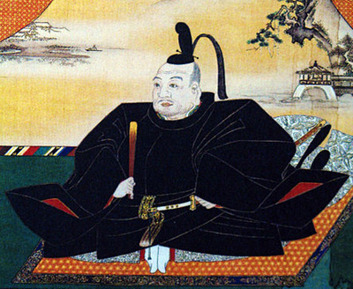
Tokugawa Ieyasu (1543-1616) was the third of the three great unifiers of Japan and the founder of the Tokugawa shogunate that ruled Japan from 1603 to 1868. The establishment of a stable national regime was a substantial achievement, as Japan had lacked effective and durable central governance for well over a century prior to Ieyasu’s rise.
Creating the Tokugawa system of rule required a variety of sweeping political and social reforms, none perhaps with a more profound impact than the division of society into four hereditary status groups (often called classes) based on occupation, known in Japanese as the shinōkōshō (samurai, peasants, artisans, merchants). In this short document, written by an unidentified retainer in the early seventeenth century, Ieyasu’s conception of the Tokugawa social hierarchy is recorded.
Tokugawa Ieyasu on Military Government and the Social Order
Once, Lord Tōshō [Ieyasu] conversed with Honda, Governor Sado, on the subject of the emperor, the shogun, and the farmer. “Whether there is order or chaos in the nation depends on the virtues and vices of these three. The emperor, with compassion in his heart for the needs of the people, must not be remiss in the performance of his duties — from the early morning worship of the New Year to the monthly functions of the court. Secondly, the shogun must not forget the possibility of war in peacetime, and must maintain his discipline. He should be able to maintain order in the country; he should bear in mind the security of the sovereign; and he must strive to dispel the anxieties of the people. One who cultivates the way of the warrior only in times of crisis is like a rat who bites his captor in the throes of being captured. The man may die from the effects of the poisonous bite, but to generate courage on the spur of the moment is not the way of a warrior. To assume the way of the warrior upon the outbreak of war is like a rat biting his captor. Although this is better than fleeing from the scene, the true master of the way of the warrior is one who maintains his martial discipline even in time of peace. Thirdly, the farmer’s toil is proverbial — from the first grain to a hundreds acts of labor. He selects the seed from last fall’s crop, and undergoes various hardships and anxieties through the heat of the summer until the seed grows finally to a rice plant. It is harvested and husked and then offered to the land steward. The rice then becomes sustenance for the multitudes. Truly, the hundred acts of toil from last fall to this fall are like so many tears of blood. Thus, it is a wise man who, while partaking of his meal, appreciates the hundred acts of toil of the people. Fourthly, the artisan’s occupation is to make and prepare wares and utensils for the use of others. Fifthly, the merchant facilitates the exchange of goods so that the people can cover their nakedness and keep their bodies warm. As the people produce clothing, food and housing, which are called the ‘three treasures’, they deserve our every sympathy.”

QUESTIONS
- How does Ieyasu conceive of the roles and responsibilities of the Emperor and the Shogun?

- How does Ieyasu justify the society hierarchy in Tokugawa Japan?

- How do Ieyasu’s ideas reflect Confucian philosophy? How has that philosophy been adapted to suit the realities of Tokugawa Japan?

- Why do you think Ieyasu wanted to create a strict social hierarchy in Japan?

