The Schism of 1054
West (Rome) Vs. East (Constantinople)
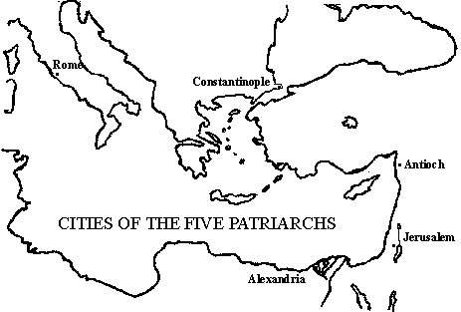
For centuries Christian values were shared by both Rome and Constantinople yet there were many disagreements concerning doctrine [beliefs] and practices. There were some minor differences such as western priests shaved their beards and used unleavened instead of leavened bread when saying Mass.
Other more substantive theological matters such as the precise relationship between God, Jesus, and the Holy Sprit caused problems.
There was also a power struggle between the Roman Pope and the Patriarch of Constantinople. Should the papacy of Rome be considered the sole seat of authority for all Christendom? And if so, does the Pope have power over the Byzantine Emperor? If the Pope crowns a Germanic King such as Charlemagne proclaiming him as the “Holy Roman Empire” is the Pope really undermining the Byzantine Emperor’s claim as the true Roman Emperor and his claim to western European Lands?
One more fundamental difference is outlined below- this was called the iconoclast debate.
Rome | Constantinople
Leader: Pope  Allowed the use of icons, religious images used by Christians to help in prayers. | Leader: Patriarch  Banned the use of icons, religious images used by Christians to help in prayers. (this ban is reversed after 100 years)

This argument and other disagreements concerning Christian teachings led the patriarch and the Pope to mutually excommunicate each other (kick each other out of the church). This split in Christianity is called a Schism or permanent split and it created two churches…
The Roman Catholic Church The Eastern Orthodox Church

The SCHISM OF 1054
In 1000 CE 5 bishops led the Church.
Christian Bishops in the East and the West disagreed on many topics in Church doctrine or church teachings. One question that could not be resolved was…
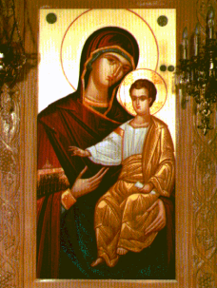
Should Christians pray to Icons (religious images)
to help them in their devotion to the Christian Faith?

This is a difficult question because one of the 10 Commandments states

- Thou shall have no other gods before me.
- Thou shall not make any graven image, or any likeness of any thing that is in heaven above…

Western Europe | Eastern Europe
The Pope in the west says… | 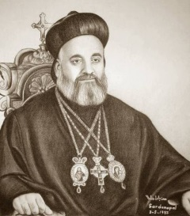  The Emperor in the East says… No, his people are not to pray to icons. Some of his supporters became ‘iconoclasts’ or icon-breakers’.  The Patriarch, or leader of the Eastern half of the Catholic Church is forced to agree with the emperor

- What is an icon?

- Why does the Emperor of the Byzantine Empire ban or outlaw prayer to icons?

- What is the Pope’s (leader of Catholic Church in Rome) opinion on this issue?

Roman Catholic | Greek Orthodox
- Western Roman Empire  - Services were always conducted in Latin  - The Pope (technically) has authority over all other bishops and kings in western Europe  - Priests can NOT marry  - Divorce is not permitted | - Byzantine Empire or Eastern Roman Empire  - Services conducted in Greek or local languages  - The Emperor claims authority over the Patriarch and other bishops of the Empire  - Priest can marry  - Divorce is allowed under certain conditions

- Who has more power, a Byzantine Emperor or the Patriarch?

- Who has more power, a European King or the Pope?

- In your own words describe what the Schism of 1054 was.

- What could be the advantage of conducting church services in the local language?

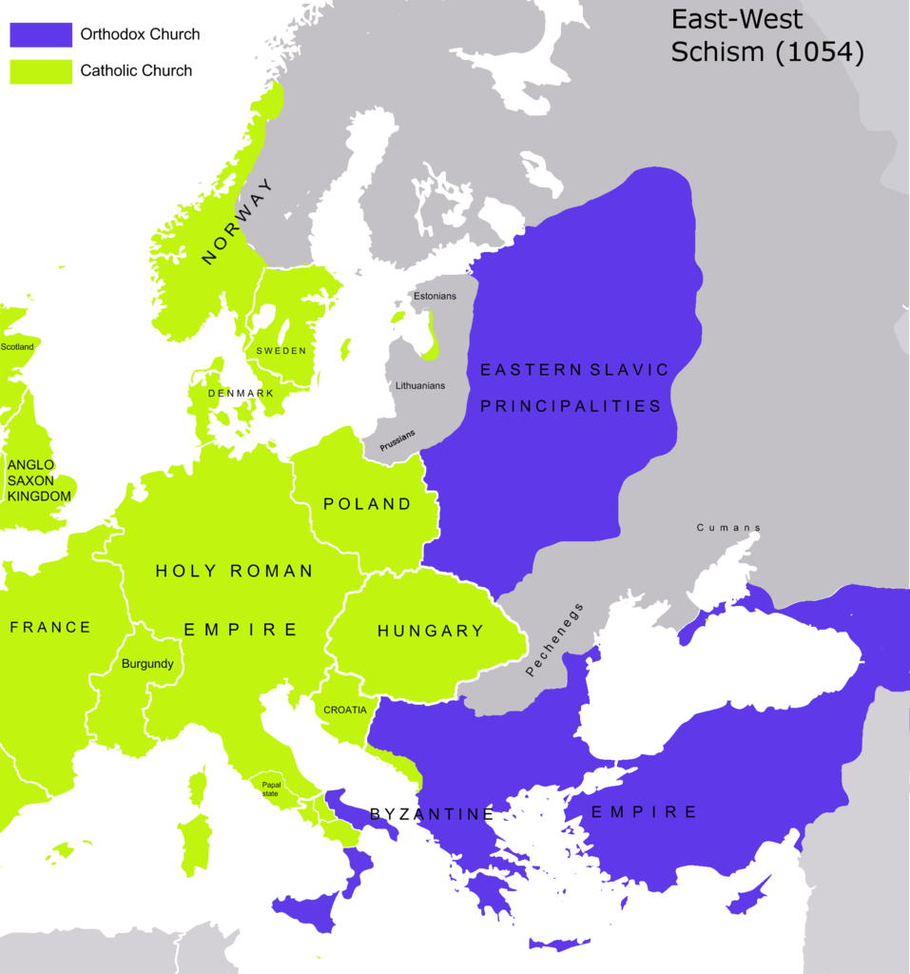

Connection to Today
Today, the Orthodox Church has about 218 million members worldwide. Roman Catholics number about 968 million.
In 1965, the two churches met to discuss their differences and explore the possibilities of reunion. Statements issued in the late 1980s outlined areas of agreement. Both churches believe that Jesus established seven sacraments, or ceremonies for Christian worship. Of these sacraments, they consider Holy Communion as the most important.
They also agree on the need for priests in the Church. However they still disagree on the role of the Pope, the issue of divorce, and on whether priest can marry.

