Han Dynasty-Power and Administration
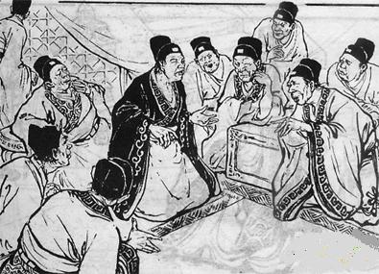
The Han dynasty became China’s formative empire, extending Han rule in all directions. The Han relied on conscripted labor and state revenues from state lands, along with a land tax. The western Han dynasty (206 BCE–9 CE) was marked by economic prosperity and expansion of the empire. After a usurper seized power from 9 to 23 CE, the Han claimed authority and the eastern Han dynasty lasted from 25 to 220 CE.
In order to secure support, Liu Bang provided land grants to his military supporters and relatives who had helped to overthrow the Qin. Power came from the ruling family, whose kin were made nobles and given land over which they had direct power. Governors who administered the commanderies [provinces] remained under central control, and a grand counselor headed the civil bureaucracy drawn from the educated men representing powerful local communities. The Han-centralized bureaucracy became an enduring source of state power. The Han court soon tightened its control over regional administration and removed powerful princes or regional lords. Regional officials came to govern these aristocratic [noble-controlled] regions as commanderies [provinces] of the empire. A civilian official and military commandant administered each commandery [province], each with immense responsibilities. They were accountable for political stability and the collection of taxes.
1) How did Liu Bang ensure the loyalty of his supporters? How did he structure his government?

2) How did Liu Bang centralize authority in his empire? What is a commandery?

The Han Dynasty-Foundations of Han Power
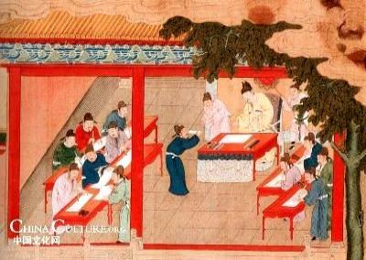
The state established schools to promote the scholar-official ideal, and eventually established a university with over 30,000 members who studied not only the Confucian classics but numerous aspects of the natural world. Officials selected students on the basis of recommendations, and at graduation these young men began careers in the bureaucracy. Increasingly, local elites encouraged their sons to become masters of Confucianism as a means to enter and advance in the ruling class. The Confucian classics soon became the heart of the autocratic state and this eventually became the civil service exam system (IMPORTANT). Over time, a bureaucratic political culture emerged that balanced the interests of the authoritarian [dictatorial] emperor with the officials he needed to rule—a partnership between China’s rulers and its educated and economic elites.
The Han Empire was distinguished by a tight-knit alliance between the imperial family and the new elite—the scholar-gentry class—who united in their effort to impose order on Chinese society. Economic and social supports, as well as a strong military and bureaucratic administration, contributed to the strength, expanse, and longevity of the Han Empire.

1) How was the bureaucracy of the Han filled with qualified men?

2) What was taught at the state-sponsored university? Why is this significant?

The Han Dynasty-the New Social Order and the Economy
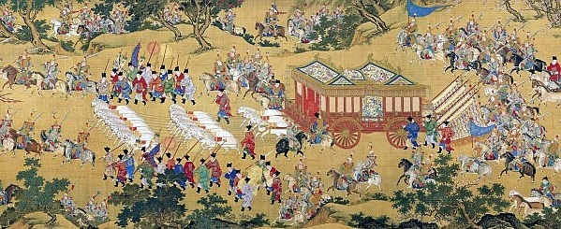
The genius of the Han was their ability to win support of diverse social groups by forming alliances with key leaders. A large number of farmers provided the Han with tax revenues, as did a variety of special revenue sources, such as tribute from outlying domains of barbarians. The state also promoted growth in silk and iron production and established state monopolies in salt, iron, and wine to fund military campaigns. Government monopolies undercut the independence of merchants, forcing them to become partners with the rulers.
Social Hierarchy- At the base of Han society was a free peasantry who owned and worked their own land. Peasants were honored for their productivity while merchants were subjected to a range of controls. Poor tenant farmers and hired laborers scratched out an existence, and at the bottom of society resided criminals and slaves, who represented a small percentage of the population. Confucians and Daoists supported this hierarchy. The empire’s most loyal social group was the scholar-officials, who linked the imperial center with local society. By 99 BCE, local uprisings forced the Han to relax its efforts to control local lords, and landlords and local magnates became the dominant powers in the provinces.
Religion and Omens- Under the Han emperor Wu, Confucianism slowly took on religious overtones with Confucius possessing aspects of divinity. Religion linked scholars and officials to the peasantry. A cluster of disasters or signs was taken as a sign that the emperor had lost the mandate of heaven.
1) How did Han rulers reduce the influence of merchants?

2) Describe the social hierarchy. What were the key groups that were important in Han China?

3) How did Confucianism begin to change under the Han dynasty?

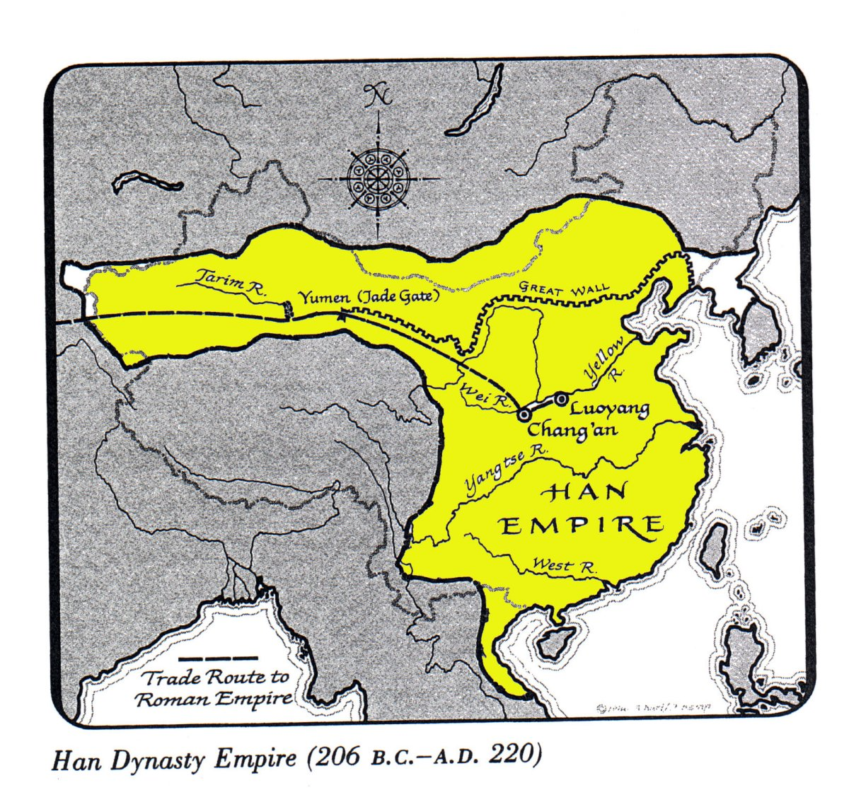
The Han Dynasty-The Expansion of the Empire and the Silk Road
The Han created a powerful army that expanded the borders of the empire and created stable conditions for the transit of goods over the Silk Road. Emperor Wu made military service compulsory. Conscripts served in their local areas. The standing army totaled more than one million men.
Expanding Borders- The army expanded borders in all directions, including into northern Vietnam and Korea but struggled more in the south and southwest due to mountainous terrain and malaria.
The most serious military threat to the Han came from the nomadic, barbarian peoples to the north, especially the Xiongnu. Emperor Wu launched offensive campaigns against the Xiongnu, eventually splitting the Xiongnu tribes in half. The southern tribes surrendered to the Han, while the northern tribes moved westward.
The Chinese Peace: Trade, Oases, and the Silk Road
After the defeat of the Xiongnu, a Pax Sinica ensued that allowed a period of extended peace and prosperity. Long-distance trade flourished, and the Han enjoyed tribute from peoples far outside the Han territory. The Xiongnu even began to serve as middlemen in the Silk Road trade. Wu extended the northern defensive wall and established a series of garrison cities. Military and farming settlements began to develop this area with support from the government. A similar system of oases was developed on the rim of the Taklamakan Desert. Traders could now find food and fodder along this route, which soon became part of the Silk Road.
1) Where did the Han expand to, and what threats were there to their military?

2) What role did the Silk Road play in the Han dynasty's policy of expansion?

3) Why is trade useful to an empire?

SOCIAL CONVULSIONS AND THE USURPER
The vast Han army stretched over long distances requiring huge expenditures. Emperor Wu raised taxes, which strained the small landholders and peasants, but by the beginning of the first century CE the Chinese empire was financially drained. Economic decline ensued as natural disasters led to crop failures. Many free peasants fell into debt and were forced to sell their land to large landholders. The social fabric of Han society tore apart as fast-growing populations confronted land shortages. Rebel movements soon formed. Wang Mang, a Han minister, seized the throne, believing the Han had lost the mandate of heaven. Wang Mang enacted reforms to help the poor and sought to redistribute land equitably. He increased taxes on artisans, hunters, and silk weavers to pay for a storehouse system to alleviate grain shortages, but his reforms failed.
NATURAL DISASTER AND REBELLION
Wang Mang’s reign was quickly undermined by a violent upheaval that united peasants and large landholders against central authority. In 11 CE, the Yellow River broke its dikes and switched course to the south. The entire region was plunged into famine and banditry, affecting nearly half of China’s population. Wang Mang’s regime was unable to cope with the disaster. Daoist clerics led a march on Wang’s capital, and by 23 CE, they had overthrown Wang Mang. The Han returned to the throne and repudiated Wang Mang’s reformist policies as well as adopting a conservative ethos favoring hereditary privilege.
THE LATER HAN DYNASTY
The Later Han dynasty restored Han rule by accepting social, political, and economic inequalities. These problems slowly diluted the central power of the emperor and the court into the hands of great aristocratic families who obtained even more private property and turned free peasants into tenants. Social turmoil emerged as inequality grew, and full-scale rebellion erupted in 184 CE. Popular religious groups championed new ideas among commoners and elites, and Daoist ideas gained popularity. At this propitious moment, Buddhist clerics arrived in northern China preaching a new religion of personal enlightenment for the elite and millennial salvation for the masses, and their ideas were warmly welcomed. Yet Daoism offered the greatest challenge to the Han dynasty as Daoist masters challenged Confucian ritual conformity. Religious groups such as the Yellow Turbans emerged across the empire and championed Daoist millenarian movements. As agricultural conditions further deteriorated, people refused to pay their taxes or provide forced labor, and internal wars engulfed the Han dynasty. After the 180s CE, three competing states replaced the Han.

