The Fall of the Byzantine Empire

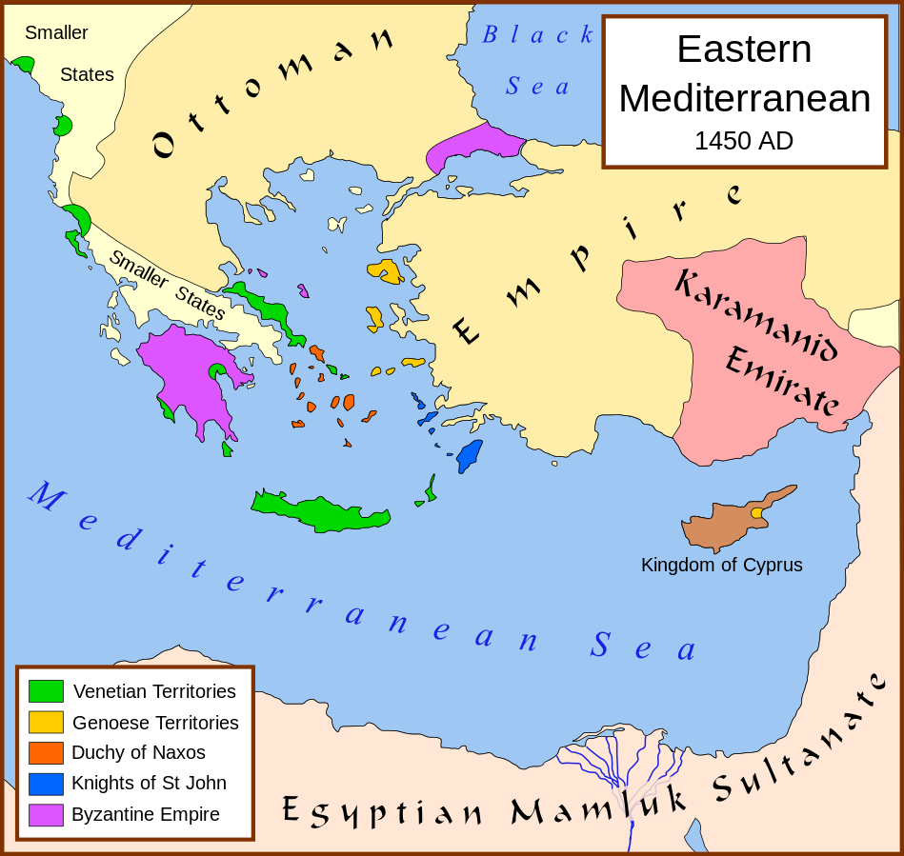
After the fall of the Western Roman empire in 476 CE, the eastern half of the empire (Byzantine Empire) remained for another near 1,000 years until the fall of Constantinople in 1453. For those 1,000 years, the Byzantine empire carried on the legacy of Rome, with monumental architecture, autocratic emperors, trade, a cosmopolitan capital in Constantinople, and expanded Christianity to Eastern Europe and Russia. As Western Europe ground under the oppression of the Dark Ages and lost much of the knowledge and learning of Greece and Rome, the Greek-speaking Byzantines continued to call themselves "Romans". But over those 1,000 years, the empire faced defeat after defeat: first, the Muslim Arabic invasions, then Turkish invasions of Anatolia (modern-day Turkey), then the disastrous Fourth Crusade, when Constantinople itself was seized by Western, Catholic Christians who originally set out to fight against Islamic warriors in the Holy Land. They never got there and the irreversibly damaged the empire. Inept emperors and constant civil war further weakened the empire, while there were often several noblemen claiming the throne at once. While the loss of lands meant a loss in tax revenue, reducing the ability of emperors to pay their soldiers and feed their citizens.
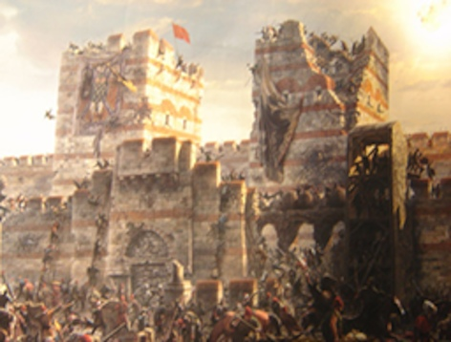
In short, by the 1400's, the empire was a shell of its former self, reduced to just Constantinople and a few surrounding regions (see box on map above). It was ripe for the taking and the Ottoman Turks were prepared to conquer the greatest Christian city in the world at last. Through the usage of gunpowder, the Turks battered down many of the city's formidable defenses and eventually overwhelmed the outnumbered defenders (see picture at right). The last Byzantine emperor, Constantine XI, appropriately named after the founder of the city, died fighting in the streets. His body was never found.
AFTERMATH OF THE FALL OF CONSTANTINOPLE
Ottoman losses during the siege are not known, but it is believed that the defenders lost around 4,000 men. A devastating blow to all Christians, the loss of Constantinople led Pope Nicholas V to call for an immediate crusade to recover the city. Despite his pleas, no Western monarch stepped forward to lead the effort. A turning point in Western history, the Fall of Constantinople is seen as the end of the Middle Ages and the beginning of the Renaissance. Fleeing the city, Greek scholars arrived in the West bringing with them priceless knowledge and rare manuscripts. The loss of Constantinople also severed European trade links with Asia leading many to begin seeking routes east by sea and keying the age of exploration. The Ottoman Turks continued their expansion into Europe and would not be truly stopped until 1683 at the siege of Vienna, over two centuries after Constantinople. For Mehmed, the capture of the city earned him the title "The Conqueror" and provided him with a key base for campaigns into Europe. The Ottoman Empire held the city until its collapse after World War I.

QUESTIONS
1) What were the causes of the fall of the Byzantine Empire? Rank them 1- and explain why you chose that order.

2) How did the Turks successfully take Constantinople?

3) What effects did the fall of the Byzantines have on the West (Western Europe)?

