The Congress of Vienna

Objectives:
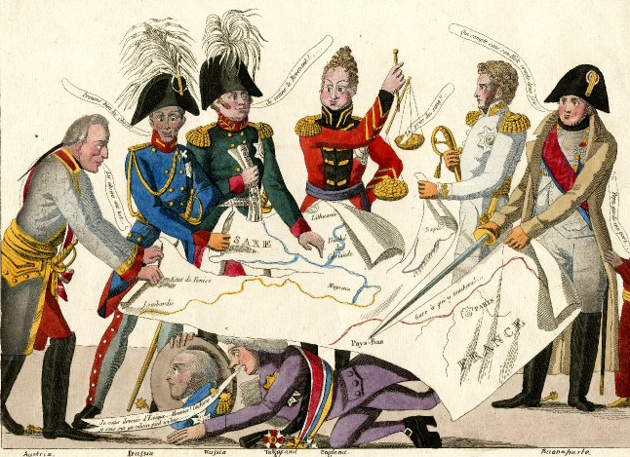

Liberalism vs. Conservatism

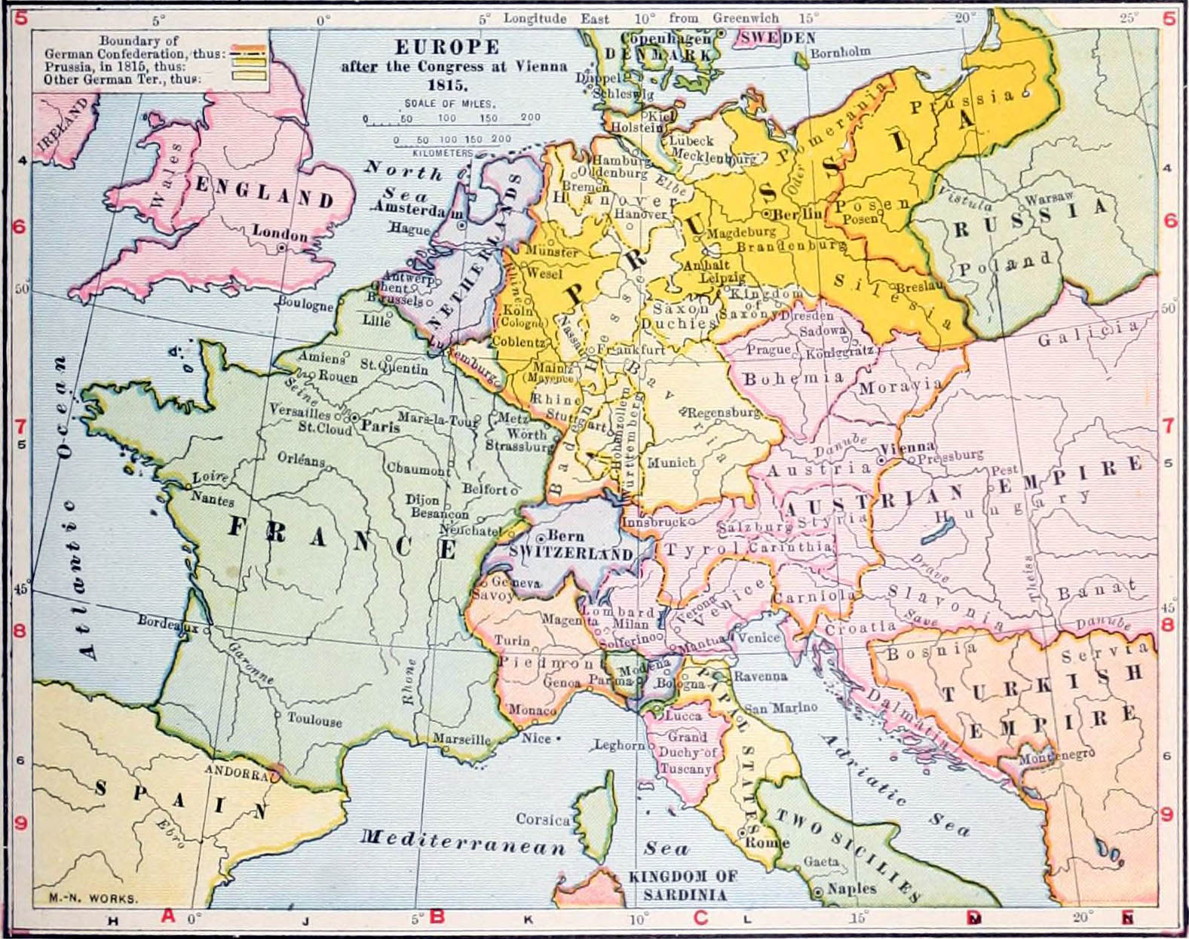

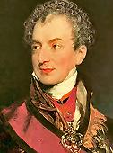
Major Players

Prince Metternich

Talleyrand

Czar Alexander I

King Frederick William III

Viscount Castlereagh

