The Battle of Thermopylae

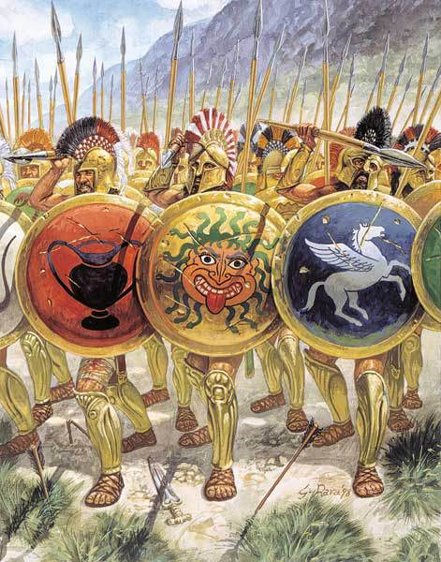
In one of the famous battles of ancient history, the Persian force met a much smaller Greek army at a narrow mountain pass called Thermopylae. Adapted from Herodotus.
King Xerxes pitched his camp in the region of Malis, while on their side the Greeks occupied the straits. These straits the Greeks in general call Thermopylae (the Hot Gates); but the natives, and those who dwell in the neighbourhood, call them Pylae (the Gates). Here then the two armies took their stand.
The Greeks who at this spot awaited the coming of Xerxes were the following:- From Sparta, three hundred men-at-arms; from Arcadia, a thousand Tegeans and Mantineans, five hundred of each people; a hundred and twenty Orchomenians, from the Arcadian Orchomenus; and a thousand from other cities: from Corinth, four hundred men; from Phlius, two hundred; and from Mycenae eighty. Such was the number from the Peloponnese. There were also present, from Boeotia, seven hundred Thespians and four hundred Thebans...
The various nations had each captains of their own under whom they served; but the one to whom all especially looked up, and who had the command of the entire force, was the Spartan, Leonidas...

Later, the Spartans stay behind to let the rest of the Greek army escape...

By this time the spears of the greater number were all shivered, and with their swords they hewed down the ranks of the Persians; and here, as they strove, Leonidas fell fighting bravely, together with many other famous Spartans, whose names I have taken care to learn on account of their great worthiness, as indeed I have those of all the three hundred...
Here they defended themselves to the last, such as still had swords using them, and the others resisting with their hands and teeth; till the barbarians, who in part had pulled down the wall and attacked them in front, in part had gone round and now encircled them upon every side, overwhelmed and buried the remnant which was left beneath showers of missile weapons.
Thus nobly did the whole body of Spartans behave...
The slain were buried where they fell; and in their honor, nor less in honor of those who died before Leonidas sent the allies away, an inscription was set up, which said:-
Go now, stranger, and to Sparta say
For all their tomorrows, we gave our today.

1) How does this passage demonstrate the political make-up of Greece at the time of the Persian Wars?

2) What does this battle demonstrate about Greek city-states? What qualities are demonstrated in the passage?

3) The Spartan king and his bodyguard stayed behind and sacrificed themselves to allow the rest of the Greek army to escape. What does this say about Greeks during a time of crisis?

4) The Greeks ultimately defeated the Persian empire. What do you think happened in Greece in after their victory?

