The 3rd Punic War
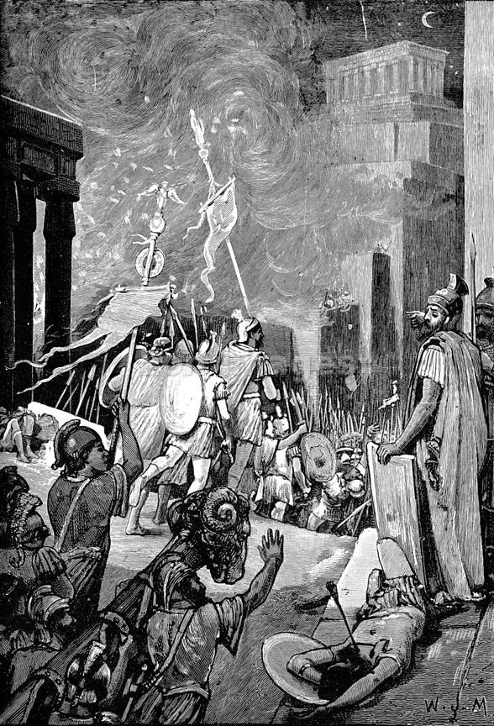
In 146 BCE, Rome wiped Carthage off the map of the North Africa. For years since the 2nd Punic War, Roman politicians had wanted to find an excuse to finally destroy Rome's worst enemy, now weakened and consisting of only the city itself and some surrounding lands. One Roman leader, Cato the Elder, would end every single speech he gave, regardless of the topic, with the phrase "Carthago delenda est": translated as "Carthage must be destroyed." Finally, at the urging of politicians like Cato, the Romans demanded the Carthaginians abandon their city and surrender their weapons. Carthage refused of course, knowing that handing over their weapons was a death sentence, but Rome, after several years of siege and fighting, completely obliterated the city: nearly 200,000 civilians and soldiers died. It is said that the Roman general who ordered Carthage's destruction had his soldier pour salt over the remains of the city, so that no crops could grow in the soil. It was a brutal end for what was once a great city but it sent a message to all the enemies of Rome.

QUESTIONS
1) What happened to Carthage?

2) Do you feel this action was justified? Why/why not?

3) What does this passage demonstrate about the character of the Romans? Be specific.

