Name: Date:
Global History 9H Mr. Lipari
ANCIENT SPARTA

Sparta was one of the most important Greek city-states throughout the Archaic and Classical periods and was famous for its military prowess. The professional and well-trained Spartan hoplites with their distinctive red cloaks, long hair, and lambda-emblazoned shields were probably the best and most feared fighters in Greece. The city was also in constant rivalry with the other major Greek cities of Athens and Corinth.

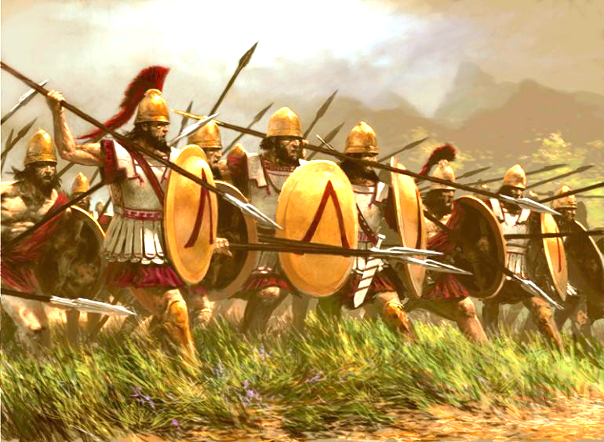
ESTABLISHING REGIONAL DOMINANCE
Sparta was located in the fertile Eurotas valley of Laconia in the southeast Peloponnese.
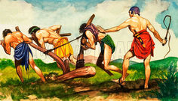
In the late 8th century BCE, Sparta subjugated most of neighboring Messenia and its population was made to serve Spartan interests. Sparta thus came to control some 8,500 km² of territory making the polis or city-state the largest in Greece and a major player in Greek politics. The lowest social group was the helots (see picture below), semi-enslaved agricultural laborers who lived on Spartan-owned estates. Spartan citizens did not take part in farming activities themselves but devoted their time to military training, hunting, war, and politics (partially to prevent a rebellion from breaking out amongst the helots). The helots could keep a percentage of the produce they cultivated, but they were also regularly purged [killed] to keep them firmly in their social place and they could also be conscripted into military duties in times of war. The relationship between citizens and helots was an uneasy one and there were sometimes uprisings.

GOVERNMENT
The Spartan political system was unusual in that it had two hereditary kings from two separate families. These monarchs were particularly powerful when one of them led the army on campaign. The kings were also priests of Zeus and they sat on the council of elders known as the gerousia. This body consisted of 28 over-60 years of age males who held the position for life. The gerousia led the citizen assembly, probably proposing issues on which to vote and it was also the highest court in Sparta. The assembly (Ekklēsia) met once a month and was open to all citizens who voted by the simple method of shouting.

SOCIETY
Like all Greek societies Sparta was dominated by male citizens and the most powerful of those came from a select group of families. These were the landed aristocracy, and citizens could not indulge in agricultural activities - this was the job of the helots - but they had to devote themselves to athletic and military training and politics. Helots could not own property and so could not rise to become full-citizens, and this lack of social mobility would come back to haunt Sparta in later centuries. Reduced by constant wars in the 5th and 4th centuries BCE, the Spartan hoplites [spear-wielding soldiers] became dangerously small in number (8,000 in 490 BCE to 700 in 371 BCE), so much so, that non-Spartan soldiers had to be enlisted and their loyalty and interest in Sparta’s ambitions was questionable.
Women in Sparta had a better lot than in other Greek city-states. In Sparta they could own property which they often gained through dowries and inheritances. In fact, women became amongst the richest members of society, as their men were killed in the many wars, and eventually controlled 2/5th of Spartan land. In addition, Spartan women could also move around with reasonable freedom, they could enjoy athletics, learn to read and write, and even drink wine. They were seen as the mothers of future warriors and thus had to be properly trained. These freedoms would have been unacceptable in other Greek poleis [city-states].
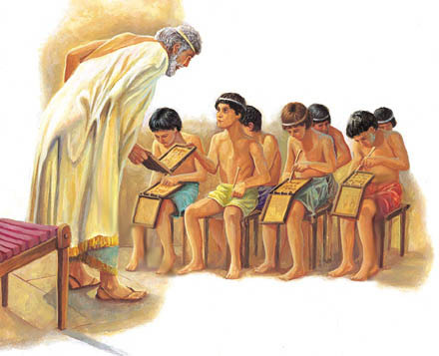
SPARTAN ARMY
Spartan life did not emphasize things like philosophy, luxury, and learning as Athens did; Spartans did not even use gold coins to purchase goods, but instead utilized iron bars as a currency. For all Spartan citizens there was a strong emphasis on military training and frugal living in communal mess halls where simple food such as barley meal, cheese, figs and wine were the norm. From the age of seven, males had a militaristic upbringing known as the agōgē where they were separated into age groups and lived in barracks (see picture at left). These youths pursued rigorous athletic and military training which became even more demanding from the age of 20, when they joined common mess halls (syssition) where they often formed homoerotic relations with older, more experienced citizens. This tough training resulted in a professional hoplite army capable of relatively sophisticated battle maneuvers and made them feared throughout Greece, a fact perhaps evidenced by Sparta’s notable lack of fortifications for most of its history.

The Spartan hoplite army, however, showed the rest of Greece the way forward towards a greater military professionalism and considering the iconic image of fearless and disciplined hoplites with red cloaks and lambda-emblazoned shields; for the Greeks, admiring Romans and even 21st century film-goers, this is Sparta.
Adapted from Ancient History Encyclopedia- Ancient Sparta

