 | Galileo Galilei | Isaac Newton | Francis Bacon | Rene Descartes
COUNTRY | Italy | England | England | France
MAJOR PUBLISHED WORK | Dialogue on the 2 Chief Systems of the World | Principia Mathematica-Mathematic Principles | The New Method | Discourse Method, Meditations
MAJOR CONTRIBUTIONS | Confirmed heliocentric model (earth around sun, rotates on an axis, moon and stars not perfect spheres), telescope, built on Copernicus, Johannes Kepler, | -Law of Universal Gravitation  -3 laws of motion  -Calculus | -Scientific Method: how all scientists do their research today | Cartesian geometry-algebra  "Ego Cogito Ergo Sum"-I think therefore I am
SIGNIFICANCE | Challenged church interpretation of the Bible, Galileo arrested, tried and put under house arrest | Basis of scientific reasoning for centuries, laws on how the universe works | Start with observations of phenomenon, THEN make theory, don't start with a theory and try to prove it | Rationalism-begin with nothing, prove one fact and then continue proving others
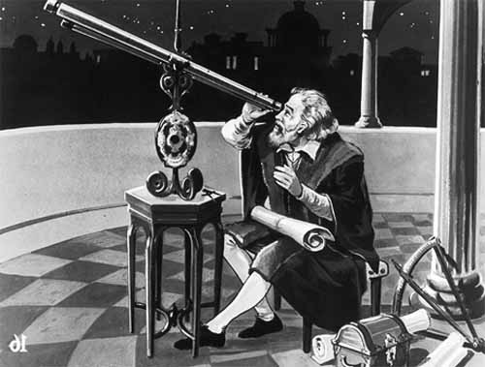
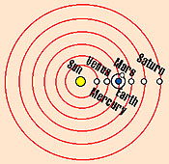 SCIENTIFIC REVOLUTION

