Ancient East Mediterranean High School Project

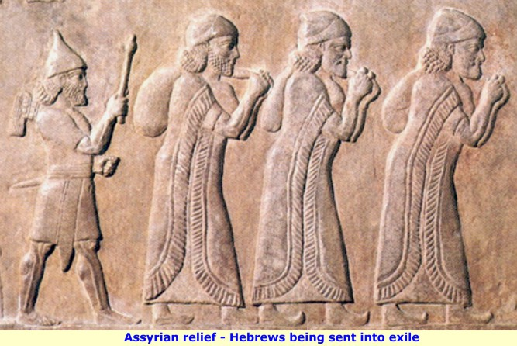
Task:
You and your team have been hired as guidance counselors by a diverse high school located in the Eastern Mediterranean. Your job is to create a class schedule that will ensure the success of all students that attend this high school. Within this high school you will have Phoenicians, Assyrians and Hebrews. Given our knowledge of these three groups, we know each is unique and must have specific classes to fit their historical needs.
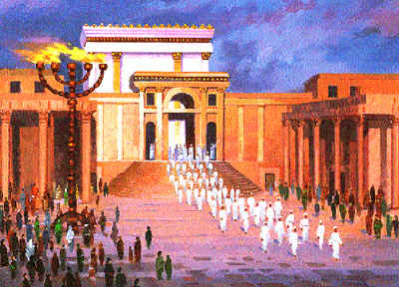
With your group it is essential that you create a full day of classes.
You must have:
1 Class for Assyrians
1 Class for Phoenicians
1 Class for Hebrews
2 Classes that all three can attend (LUNCH DOES NOT COUNT)
Students entering East Mediterranean High
For each class you must have:
A catchy title
An explanation of the class
A reason/justification why the class was created
Roughly 5-6 sentences for each class (5 classes equal 5 paragraphs)

COURSE LIST-5 paragraphs, each describing one course-50 points
CREATE A POWERPOINT-5 slides, 1 for each class-10 points
PRESENTATION-In-class presentation-10 points

Please send Powerpoints to mlipari@bellmore-merrick.k12.ny.us or have a USB drive for tomorrow, with the presentation uploaded and ready to go.

Tip: Delegate the work in your group and have individuals responsible for certain portions of the project-if you wrote a paragraph, write that

