Roman Infrastructure and Buildings
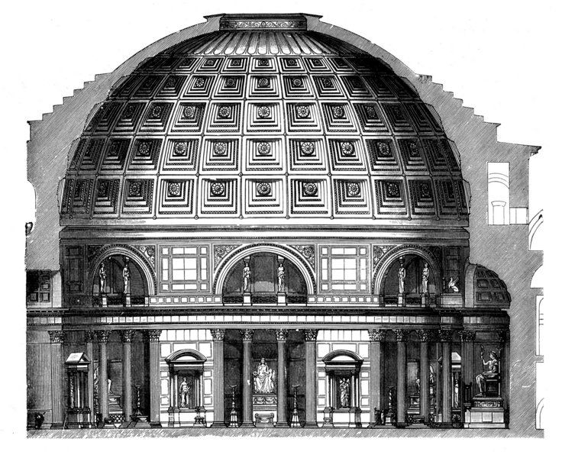
Some of the most famous buildings of the ancient world are Roman structures. What allowed for the Romans to construct such magnificent structures was the invention of concrete: a mixture of stones and cement, concrete was critical in Roman building projects, as it was strong enough to support colossal domes (also Roman invention), roofs, and arches.
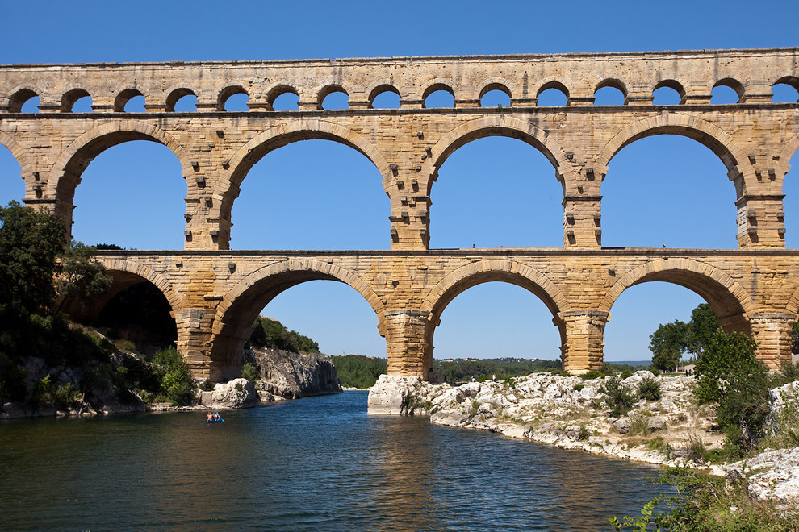
The Roman built 53,000 miles of road to connect their empire from Britain to Syria. The purpose of these many roads were many. First, the Roman army needed a reliable method of traveling through the vast empire to march to the various foreign enemies that threatened the empire. Secondly, trade and communication were paramount in an empire that required taxes and helped further cultural diffusion and make the empire more "Roman". Some Roman roads are still in use today in parts of Europe, a testament to their durability and usefulness.
The Romans beautified and organized hundreds of cities with both practical and luxurious buildings. Most importantly, aqueducts were built to draw water to the city from distant sources. This in turn provided water for drinking and bathing, improving sanitation while providing a source for great baths to be built. Taking a page from the ancient Greeks, the Romans constructed massive public baths, which provided athletic facilities for both men and women, as well as hot and cold pools for bathing. Most famously, Romans loved spectacle and sport, and so great amphitheaters like the Coliseum sprouted up across the empire. Plays, chariot races, and gladiatorial combat were common throughout the empire, and provided a distraction for the urban poor and their often-miserable lives.
