Qin Shi Huangdi
Source 1
The Records of the Grand Historian, or Shiji (史記), written from 109 BC to 91 BC, by Sima Qian.

Chapter 6 of The Shiji

Chancellor Li Si Said:
"I, your servant, propose that all historian's records other than those of Qin's be burned.
With the exception of the academics whose duty includes possessing books, if anyone under heaven has copies of the Shi Jing, the Classic of History, or the writings of the hundred schools of philosophy, they shall deliver them (the books) to the governor or the commandant for burning. Anyone who dares to discuss the Shi Jing or the Classic of History shall be publicly executed. Anyone who uses history to criticize the present shall have his family executed. Any official who sees the violations but fails to report them is equally guilty. Anyone who has failed to burn the books after thirty days of this announcement shall be subjected to tattooing and be sent to build the Great Wall. The books that have exemption are those on medicine, divination, agriculture and forestry. Those who have interest in laws shall instead study from officials.”

- Why did Shi Huangdi have these books burned?

- Were his actions justified? Why or why not?

- How is this action reflective of the philosophy of Legalism?

4. How can knowledge be a weapon in the right hands?

Source 2

Though the beginning of the Great Wall of China can be traced to the third century BCE, many of the fortifications included in the wall date from hundreds of years earlier, when China was divided into a number of individual kingdoms during the so-called Warring States Period. Around 220 BCE, Qin Shi Huangdi, the first emperor of a unified China, ordered that earlier fortifications between states be removed and a number of existing walls along the northern border be joined into a single system that would extend for more than 10,000 li (a li is about one-third of a mile) and protect China against attacks from the north. When Emperor Qin Shi Huangdi ordered construction of the Great Wall around 221 BCE, the labor force that built the wall was made up largely of soldiers and convicts. It is said that as many as 400,000 people died during the wall's construction; many of these workers were buried within the wall itself. Construction continued up to the Ming dynasty (1368–1644), when the Great Wall became the world's largest military structure. Today, the Great Wall is generally recognized as one of the most impressive architectural feats in history.
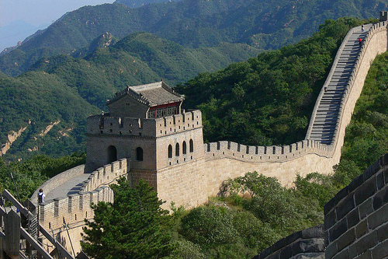
- 1. What purpose did the Great Wall serve?
2

2. What does this tell us about Shi Huangdi?

Qin Shi Huangdi

Source 3

Excerpt from A History of China, 1969

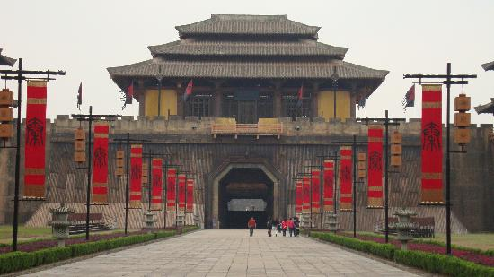
He [Qin Shi Huang Di] planned the capital in an ambitious style but, although there was real need for extension of the city, his plans can scarcely be regarded as of great service. His enormous palace, and also his mausoleum which was built for him before his death, were constructed in accordance with astral notions. Within the palace the emperor continually changed his residential quarters, probably not only from fear of assassination but also for astronomical reasons. His mausoleum formed a hemispherical dome, and all the stars of the sky were painted on its interior. In addition to this, the frontier walls already existing in the mountains were rebuilt and made into a single great system. Thus came into existence in 214 B.C., out of the blood and sweat of countless pressed laborers, the famous Great Wall. On one of his periodical journeys the emperor fell ill and died. His death was the signal for the rising of many rebellious elements. Nobles rose in order to regain power and influence; generals rose because they objected to the permanent pressure from the central administration and their supervision by controllers; men of the people rose as popular leaders because the people were more tormented than ever by forced labor, generally at a distance from their homes. Within a few months there were six different rebellions and six different rulers.

Eberhard, Wolfram. A History of China. Berkeley and Los Angeles, CA: University of California Press, 1969. Web.

- Why did Shi Huangdi constantly change where he was living?

- How was the Great Wall built?

- What happened when Shi Huandi died? What does this tell us about his personality/character?

Source 4

Shortly after completing his final conquest and establishing the unified empire in 221BC, the Qin First Emperor, accompanied by his court classicists, began to tour the newly conquered eastern regions. Here, he erected a series of stele inscriptions on the top of venerated mountains. Sima Qiam recorded the inscriptions in the Shiji.

Inscription at Mt Zhifu
The great sage initiated order, establishing laws and regulations, making manifest his rules and standards.

Abroad he instructed the feudal rulers, shedding the light of cultured blessing, enlightening them with the principles of righteousness.

The Six States were disobedient, insatiable in greed and perversity, pillaging and slaughtering endlessly.

The August Emperor, pitying the multitude, called out his chastising armies, brandishing his military power.

Through righteous punishment, trustworthy acts, he displayed his might in all quarters, till there were none who failed to submit.

He wiped out the powerful and unruly, rescuing the black-headed people, bringing peace to the four corners of the empire.

Far and wide he dispensed his enlightened laws to bind and regulate all under heaven, to stand as a model unending.

1. According to this document, what positive changes did Shi Huangdi bring to China? (Identify at least two)

2. Why did Shi Huangdi feel it was necessary to establish strict laws for the people in China?

QIN Shi Huangdi

Source 5

Excerpt 2 from China: Ancient and Modern, 1900

“This sovereign [Qin Shi Huang Di] was but thirteen years of age when he ascended the throne, but young as he was he speedily everywhere made his influence felt. He chose Hien-Yang, the modern Se-gan Fu, as the capital, and built there a magnificent palace, which was the wonder and admiration of his contemporaries. He constructed roads through the empire; he formed canals and erected numerous handsome public buildings. Having by these and other means settled the internal affairs of the kingdom, he turned his attention to the enemies beyond his frontier.” “Chief among these were the Heung-nu Tartars, whose attacks had for years kept the Chinese and neighboring principalities in a state of disquiet. Against these foes he marched an army of 300,000 men and completely routed them, exterminating those in the neighborhood of China, and driving the rest into the mountains of Mongolia.”

Miller, J. Martin. China: Ancient and Modern. Los Angeles, CA: Sanderson-Whitten, 1900. Hathitrust. Web.

1. How did Shi Huangdi improve China?

2. Do you believe Shi Huangdi to be a good ruler/leader? Why or why not?

3. What does this document tell us about Shi Huangdi's personality/character?

Source 6

When Shi Huangdi ascended as ruler of the Qin tribe in 246 B.C., China had been at war for 200 years. Seven major states were battling each other for dominance in the land, which was then a patchwork of feudal villages with no central bureaucracy [government]. After a series of victories, the Qin absorbed its last rival in 221 B.C., unifying China under one leader. As head of the new empire of China, Shi Huangdi didn't hesitate to establish a new law of the land. The Emperor quickly abolished the old feudal system, standardized the Chinese writing and currency systems, built a vast network of roads and canals to link the country and divided China into states with one centralized government.

He took the following steps:

Unification of currency. Bronze banliang coin. China, Qin dynasty, Third century BCE. The Chinese inscription on this coin reads banliang, with ban to the right of the hole and liang to the left. Banliang means “half-ounce”—the weight of the coin.

Unification of weights and measurements. Officials throughout China would have used this same weight to measure goods.

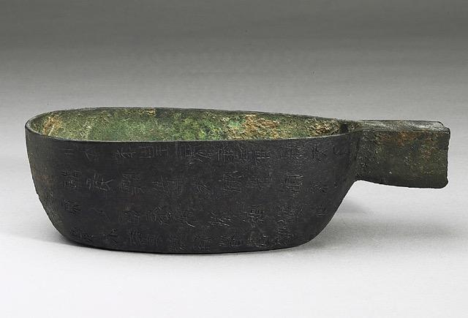

Books with the same characters.
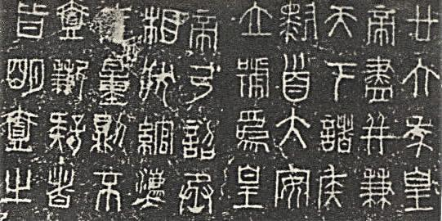
The Qin dynasty standardized the letters used to write in the empire

1. How did the changes made by Shi Huangdi improve China?

2. Which change do you think was the most important? Why?

