Problems during the Roman Republic (509 BCE-44 BCE)
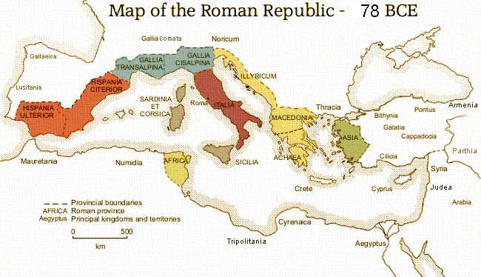
By 100 BC, Rome had expanded across the Mediterranean and conquered Greece, parts of Anatolia, Spain, and North Africa (see map).

During this time, there were drastic changes occurring within Roman Society, caused by the constant wars of conquest Rome fought in "self-defense".

1) Large Number of Slaves- the massive number of foreign slaves taken from Roman victories meant free labor was becoming less and less common, especially in the occupation of farmers, or agricolae. Massive plantation-like estates called latinfundia were taking over the smaller farms of free landowners, many of whom were away on campaign fighting for Rome (it was the duty of every Roman male to join the army in times of war). When they returned, they would find their farms sold off and themselves jobless; many went to the city seeking work or relief. This led to the creation of what is known in Roman history as "the mob", the unruly mass of people Roman leaders had to keep happy.

2) Creation of Professional Armies- Gaius Marius, a six-time consul (one of the two allowed each year) and general reformed the army and made it into a full-time professional force: all Roman males were no longer obligated to join in times of war. It was supplied and paid for by the Roman government, so citizens no longer had to pay for their own arms and armor. Gaius Marius recruited heavily from the poor and promised land grants as payment for twenty five years’ service. This in turn caused the armies to be more loyal to the general paying their pension, than to the Roman Republic.

3) Land Reform- Reform of the farming systems, especially latinfundia, became a significant issue, and two politicians named the Gracchi brothers attempted land reform several times during their political careers (around 100 BCE). They were called rabble-rousers for trying to redistribute land from the wealthy and their time in politics marked a serious increase in violence during Roman elections. Eventually, both were assassinated and nothing was done to tackle the growing gap between rich and poor. The Roman mob grew frustrated and was desperate for someone to do something to about the social problems of Rome

QUESTION
1) Draw a flow chart of the problems described above (DO NOT JUST USE THE NUMBERED TITLES). What leads to what event and how can it lead to the fall of the republic?

