Letter from Leeds Cloth Merchants, 1791

This statement by the Cloth Merchants of Leeds (a major center of wool manufacture in Yorkshire) defended the use of machines. It appeared in 1791.
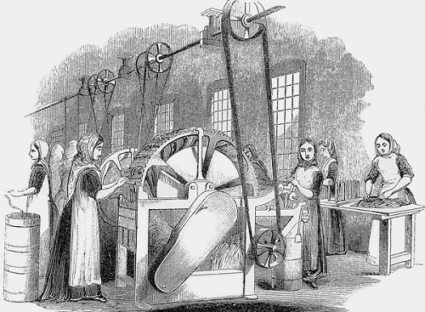
At a time when the People, engaged in every other Manufacture [business] in the Kingdom, are working to bring their Work to Market at reduced Prices, which can alone be caused by the Aid of Machinery... the Cloth Merchants of Leeds, who depend on a Foreign Demand, where they have for Competitors the Manufacturers of other Nations, whose Taxes are few, and whose manual Labor is only Half the Price it bears here, should have Occasion to defend their use of machines... they [the merchants] wish to remind the Inhabitants of this Town, of the Advantages derived from the Application of Machinery; they instance that of Cotton in particular, which in its internal and foreign Demand is nearly alike to our own, and has in a few Years by the Means of Machinery increased to its present Importance, and is still increasing.
If then by the Use of Machines, the Manufacturing of Cotton... has met with such amazing Success, may not greater Advantages be reasonably expected from... the Manufacture of Wool, the product of our own Island [Britain], a product in Demand in all Countries, almost the universal Clothing of Mankind?
**In the Manufacture of Woolens, the Scribbling Mill, the Spinning Frame, and the Fly Shuttle [new machines], have reduced manual Labor nearly One third, and each of them at its-first Introduction made the working people angry, yet each has contributed to an increase in wages and to increase the Trade...**
We the Merchants, think it a Duty we owe to ourselves, to the Town of Leeds, and to the Nation at large, to declare that we will protect and support the free Use of the proposed Improvements in Cloth-Dressing [new machines], by every legal Means in our Power; and if after all, contrary to our Expectations, the Introduction of Machinery should for a Time occasion a Scarcity of Work in the Cloth Dressing Trade, we have unanimously agreed to give a Preference to such Workmen who are now settled Inhabitants of this Parish [town], and who give no Opposition to the present Scheme.
Appleby & Sawyer, Bernard Bischoff & Sons [and 59 other names]
From J. F. C. Harrison, Society and Politics in England, 1780-1960 (New York: Harper & Row, 1965), pp. 72-74.

QUESTIONS
1) Why do the merchants say they need these machines in the first paragraph? Who are they competing against?

2) How much have these machines reduced labor costs? Have wages risen?

3) What do the merchants promise to workers who do not oppose their "scheme"?

4) What type of clothe material do the merchants import? What type does Britain have that they wish to use export finished goods?

