PREHISTORY, EVOLUTION, AND MIGRATION

Prehistory

Archaeology

Anthropology

Culture

Technology

First Human, "Lucy"

Evolution

Charles Darwin and Natural Selection
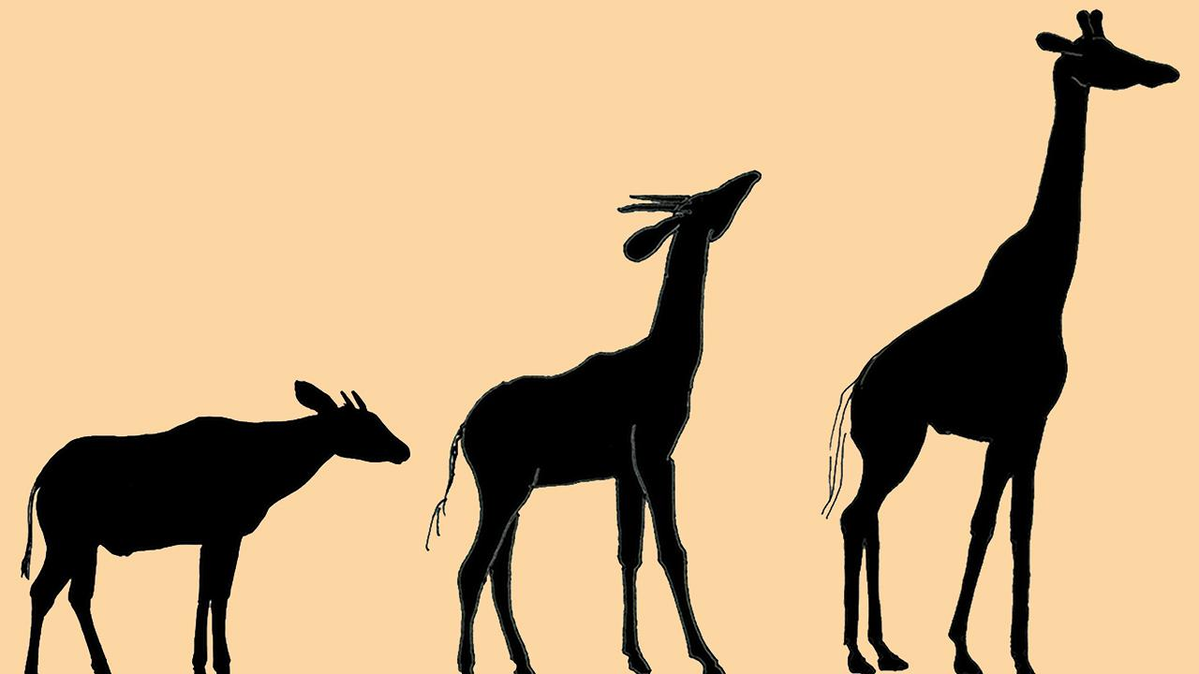
Out of Africa Theory
