1. Polynesian Origins
The physical environment of the Polynesian islands is not as favorable for human habitation as it might at first seem. It certainly presented difficulties when the ancestors of the Polynesians entered the area some 2,000 to 3,000 years ago, first settling on the western islands—Wallis and Futuna, Samoa, and Tonga—which were devoid [lacking in] of much that was needed for human habitation. As a result, early peoples had to take in a wide variety of subsistence items, including most of the useful plants and all of the domestic animals they required. The physical environment has continued to exert a marked influence on Polynesian culture.
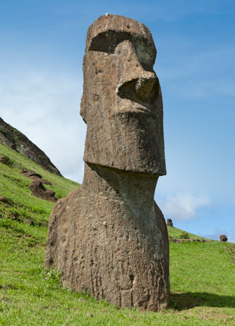
Linguistic evidence suggests that western Polynesia was first settled some 3,000 years ago, by people of the Lapita culture. It has proved harder to establish when eastern Polynesia was settled. It is possible that some islands were occupied soon after the arrival of Lapita colonists in western Polynesia. However, while the Lapita are best known for their distinctive pottery, eastern Polynesia’s archaeological sites lack ceramics of any kind. Nonetheless, it is clear that the various island groups in Polynesia interacted frequently with one another during the early period of settlement, exchanging luxury goods such as basalt adzes, pearl shell, and red feathers.

One of the principal characteristics of traditional Polynesian cultures is an effective adaptation to and mastery of the ocean environment. The Polynesians were superb mariners—their voyages extended as far as Chile, approximately 2,200 miles (3,500 km) east of Easter Island—but their mastery did not extend merely to the technology involved in shipbuilding and navigation. It also permeated social organization, religion, food production, and most other facets of the culture; they had social mechanisms for coping with the human problems of shipwreck, such as separated families and the sudden loss of large portions of the group. In short, they were well equipped to handle the numerous hazards of the beautiful but challenging Pacific environment.

Another important characteristic of traditional culture was a certain amount of conservatism. This is apparent in all Polynesian cultures, even those that are separated by hundreds or thousands of miles, and whose populations were separated two or three millennia ago. For instance, a comparison of material goods such as stone adzes and fishhooks from widely separated groups reveals a remarkable similarity. The same is true for kinship terms, plant names, and much of the rest of the technical vocabulary of the cultures, as well as for art motifs and medical preparations. The ornate and voluminous genealogies, chants, legends, songs, and spells that were passed down and elaborated through the generations show a profound reverence for the past.
Polynesian cultures displayed a thoroughly practical exploitation of the environment. Their languages reflect their systematic observations of the natural world, abounding with terminology for stars, currents, winds, landforms, and directions... Creation traditions told of the origin of the world, setting forth the order of precedence of earth, sky, and sea and their inhabitants, including man and woman. Genealogies fixed the individual tightly into a hierarchical social order. A variety of legends interpreted natural phenomena, while historical accounts often described, with varying amounts of mythological elaboration, the migrations of people before they arrived at the island on which they were located, their adventures on the way, and the development of the culture following settlement.

Violence was an ever-present element of Polynesian cultures. This is reflected in the oral literature and in all aspects of traditional life. Various customs controlled and repressed the direct physical expression of aggression within the kin group and the tribe up to a point, but there were definite boundaries of behaviour beyond which only violence could restore status or assuage injured pride. Punishments for transgressing ritual prohibitions and social rules often incorporated ritual sacrifice or even the death of the transgressor. Intertribal warfare was extremely common, particularly when populations began to outgrow available resources.

QUESTIONS
1) When did the first settlers of Oceania arrive?

2) What role did the migrations and the environment play in Polynesian creation myths?

3) Polynesian communities were separated by thousands of miles yet a common culture remained. How do we know this and how was it possible?

4) What role did violence play in society?

2. Settlement patterns and housing
Two major settlement patterns were used in Polynesia prior to European contact: hamlets and villages. Their origin and development reflected factors such as social organization, the distribution of food-crop resources, and defense considerations.

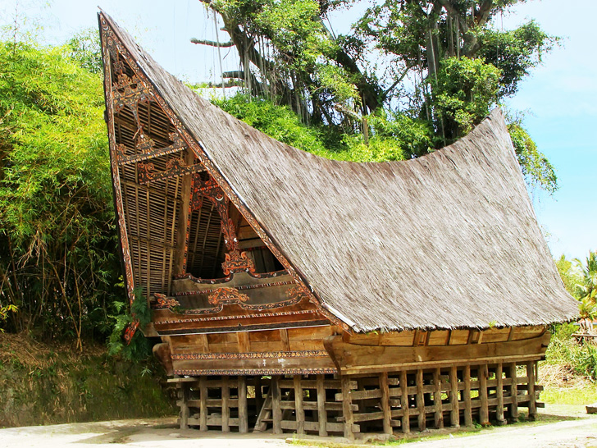
Hamlets, comprising a few households or an extended family or two, were common on the larger volcanic islands, where food resources were diversified and scattered over a range of environmental zones. A typical hamlet settlement pattern was found in the Marquesas Islands of what is now French Polynesia. There, in prehistoric times as at present, the population spread up the sides of the deep and narrow valleys in clusters of perhaps four to five houses, often with gardens, taro patches, and coconut and breadfruit trees in the immediate vicinity.

Marquesan houses were built on rectangular platforms, the height and composition of which depended on the prestige of the owner. Individuals of lower status might have a simple paved rectangle no more than a few inches high, while warriors, priests, or chiefs might live in houses perched on platforms 7 to 8 feet (2.1 to 2.4 meters) high and containing stones weighing several tons each. Most of the household activity took place on the “veranda,” or unroofed front portion of the platform, which was paved with smooth basalt stones that had been transported from streambeds. Houses of chiefs and other individuals of high status often made use of cut stone slabs for decorating the platform. Many also had rectangular pits in the platforms for storing fermenting breadfruit paste (an important delicacy) as well as small caches in which were interred the carefully cleaned and packaged bones of important family members.

In Samoa, on the other hand, the settlement pattern shifted from hamlets to fortified villages after about 1000 CE. These communities, consisting of 30 or more houses connected by a network of paths, were built along the coast. Early houses were built on rectangular platforms much like those of the Marquesas, but, by the time of European contact, Samoan houses were built on oval mounds that were faced with rough stone slabs. The typical house was large and open—oval in floor plan, with a beehive-shaped thatched roof supported by a series of stout wooden pillars. Rather than building substantial walls, people hung rolled mats along the eaves, unrolling them as necessary to protect the inhabitants from sun, rain, or the night air. Houses were arranged in orderly fashion within the villages, which in turn were surrounded by a fortification wall of stone or by wooden palisades.

The Maori of New Zealand constructed particularly large and impressive fortified villages (pas) on hilltops, surpassing those of all other Polynesian cultures. Ditches, palisades, trenches, and terraces protected these forts. The interiors were partitioned off by additional defensive works to facilitate battle even after the outer defenses had been penetrated by an enemy assault. Maori houses were made of timber, rectangular in plan, and generally dug about 1 foot (0.3 meter) into the earth’s surface.

QUESTIONS
1) How did housing show social status in Polynesian culture? Use evidence from the passage.

2) Describe the difference between a hamlet and a village.

3) How were fortified villages on Samoa and New Zealand geared for warfare? What does this tell us about Polynesian culture?

4) Compare to European castle-building: why did Europeans need to start to build castles and develop the feudal system?

3. Kinship and social hierarchy
The typical Polynesian family consisted of three or more generations. Polynesian kinship terminology distinguishes between generations, as might be expected in a society so strongly oriented toward tradition and genealogy.

Kin groups were also the basis for Polynesian social hierarchies. In general, people traced their ancestry through the male line, a system in which children belong to their father’s lineage (patrilineality). After marriage most couples resided with the husband’s family (patrilocality). Thus, a typical family consisted of a senior male, his sons and grandsons, their spouses, and the group’s unmarried children.

However, although patrilineality was the most common method for reckoning ancestry, there were many variations from this system. In Hawaii, Tahiti, and elsewhere, and especially if it was to one’s advantage, descent could be traced through women (matrilineality). Thus, while descent through the male line was notionally preferred, in practice the descent system was often bilateral—traced through either or both parents. Adoption was very common and increased the flexibility of the kinship system by gathering additional parents to a child (and vice versa) rather than replacing the child’s biological parents. Siblings and cousins frequently adopted one another’s children, and grandparents sometimes adopted their own grandchildren. Children were thus able to move freely among all of these families and households.

QUESTIONS

1) Explain how family ties were flexible in certain Polynesian cultures?

2) Compare Polynesian family dynamics with those of China.

3) Would you infer that Polynesian had a strict social hierarchy or a loose hierarchy based on this passage?

4. Stratification
Social stratification was an inherent feature of Polynesian society, and cultures generally had social classes that were clearly defined in terms of rights, duties, behavior, and lifestyle.
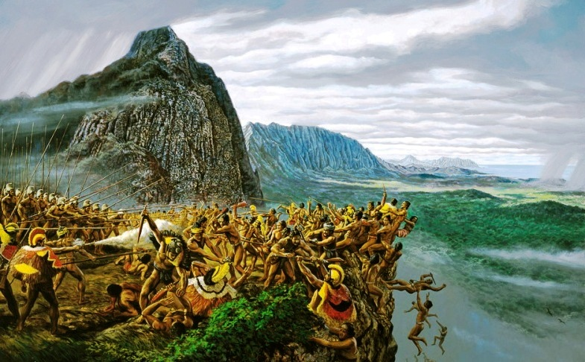
In many Polynesian societies, the chief was the person of highest status, yet he was often regarded by his people and generally conducted himself as merely “first among equals.” In most of the more traditional of the societies, the chief could not appropriate the land of his followers, nor did he appear to be too interested in increasing his own group’s holdings at the expense of neighboring groups. In terms of his clothing and behavior, little distinguished him from other males. Nevertheless, he was the source of sacred power for the group, a symbol of its ties with the past, and the vehicle whereby these ties would be perpetuated for coming generations. However, it was possible for a man to rise in prestige by various achievements—by giving gifts, holding feasts, or displaying military prowess, for example.
Many Polynesian societies, such as those on the islands of New Zealand, Hawaii, and Tonga and on the Society Islands, developed complex social hierarchies with ranked lineages and powerful chiefs. These chiefly rankings were derived from the Polynesians’ concept of the inheritance of godliness and, as a result, the chief’s possession of mana. Chiefs also differed from others in their ability to lead in battle, their success in accumulating and distributing large amounts of food and other valuables, and their religious skills in communicating with the gods.
1) Describe the role of the chief and his power within Polynesian society.

2) Compare the role of the chief to other leaders at the top of social pyramids of China, Japan, Europe, etc. What is similar, what is different? Be specific in your evidence.

5. Production and technology

Fishing
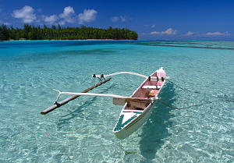
The sea provided most of the protein in the traditional Polynesian diet. Fishing was done by individuals, with spear, line, or net, and also by groups. In the latter case, large numbers of men sometimes spread and hauled in huge nets in bays or lagoons and at other times drove fish toward shore, where they could be captured in nets held in shallow water. In some Polynesian societies (the Marquesas and Samoa, for example), specialists directed the mass fishing efforts and the elaborate religious rituals that went along with them.
Polynesians did not confine their fishing exploits to coastal waters, for they were equally at home on the high seas and explored for miles in all directions. The people of Easter Island, for example, were known to fish at Sala y Gómez reef, a journey of some 300 miles (500 km).
Various types of seaweeds and algae were also collected and were highly prized for their salty taste. There was, in short, nothing edible in the sea that was not food for the Polynesians.

Gardening
Although Polynesians were mariners above all, they were also devoted to horticulture and arboriculture, producing the staples of the Polynesian diet and most of their condiments in gardens and groves. The major native crops were yams (Dioscorea species), taro (Colocasia esculenta), breadfruit (Artocarpuscommunis), bananas (Musa species), sugarcane (Saccharum species), coconuts(Cocos nucifera), and Tahitian chestnuts (Inocarpus edulis). These crops achieved different levels of importance in various Polynesian societies, depending on cultural factors and environmental conditions. The Hawaiians, for example, relied heavily on taro, building extensive irrigation systems to grow the variety that requires muddy soil and planting the “dry” variety in the uplands.

As with the coconut, most food plants in Polynesia also provided materials for other purposes. The breadfruit tree furnished wood for the hulls of dugout canoes, and the milky sap of the fruit itself was used in caulking the gaps between the planks of larger canoes. The black mud of the taro patches was used to stain wood and stone carvings. The pandanus fruit was highly prized as a kind of chewing gum, as well as a major component of floral necklaces and headpieces, to which it contributed its strong and pleasant colour. Pandanus leaves, when bleached, became the raw material for weaving fine mats. The candlenut was used for torches. Its oil was a cathartic, and its wood furnished certain canoe parts.

QUESTIONS

1) What were some of the main crops of Polynesia? What overlap is there with other post-classical civilizations?

2) What did Polynesians consume most of their protein from?

3) How far would some Polynesians travel to fish? How is it possible that they could do this on a regular basis? What skills were necessary?

4) What other uses did the crops of Polynesia provide?

6. Religion
Polynesian belief systems emphasized animism, a perspective in which all things, animate and inanimate, were believed to be endowed to a greater or lesser degree with sacred supernatural power. That power, known among Polynesians as mana, could be nullified by various human actions, and many of the region’s tapu (“prohibitions” or “taboos”) were intended to prevent such behaviors.
As is typical of animist cultures, religious concerns permeated all aspects of life. Polynesian chiefs had great mana—so great, in fact, that in some societies, if a commoner touched the chief’s shadow, only that person’s death could compensate for the injury to the chief’s mana. In much of Polynesia it is still considered to be in very poor taste to step over a person’s legs, pass one’s hand over a person’s head, or stand with one’s head higher than that of a person of high rank, because these actions are believed to sap a person’s mana.
Women had great mana, the evidence of which was their ability to reproduce. Many tapu were created to ensure the mutual protection of women’s mana and the mana of other people and objects. In the Marquesas islands, for example, a tapu prohibited women from entering canoes under normal conditions because their mana and that of the canoe would compete. Men had lesser mana and needed to protect it carefully; in many societies, men preparing for war or other hazardous or demanding undertakings had to go through a period of purification—eating only certain foods and often going into seclusion to protect their powers from defilement.
Mana was possessed not only by people but also by buildings, stones, tools, and all other things. Certain groves, trees, temples, and tracts of land were considered sacred and could not be entered by ordinary people because they were pervaded by the mana of a high-status person or god. If anyone inadvertently stepped over a tool left on the ground, it was thus rendered profane and would often be discarded. Violations of these and other lesser tapu were believed to result in supernatural punishment, manifested in bad luck or some form of illness.
Mana and tapu were not the only forces that Polynesians had to be wary of, however. The universe was believed to be peopled with spiritual beings of various types, many of whom were malevolent. In addition, a host of gods of varying degrees of importance existed. These ranged from the great gods of the Polynesian pantheon, such as Tangaroa, Tu, and Lono, to strictly local gods who were deified priests or chiefs of great renown. All of these spirit-beings had to be worshipped in their own way. Worship of the gods involved sacrifices (including human), chants and recitations, feasting (often with great prodigality), ritual sex (to promote fertility), and other elaborate practices, often preceded by long fasting and abstinence.
Magic flourished in Polynesian society; everyone engaged in actions to ensure success in love, war, planting, or fishing or to bring misfortune to rivals. Magical specialists could be consulted when the problem at hand was too great or complicated to be solved by ordinary magic. Some magical practices have survived in Polynesian cultures to the present time.

QUESTIONS
1) Describe the concept of mana and its importance in Polynesian religion.

2) How does one preserve his or her mana?

3) What general gods are shared amongst the Polynesian people?

4) Compare mana and tapu to karma/dharma in Hinduism and one's soul and sin in Christianity

From Encyclopædia Britannica

