Johan Goudsblom“The Civilizing Process and the Domestication of Fire,” Journal of World History, 3/1 (Spring 1992).

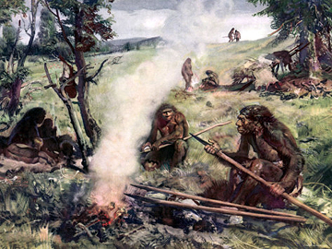
The human domestication of fire around 400,000 years ago has had far-reaching consequences, and it deserves to be ranked as the first great ecological transformation brought about by humans, followed very much later by two transformations of the same order: the emergence of agriculture and animal husbandry (agrarianization) some 10,000 years ago, and the rise of large-scale industrial production (industrialization) some two centuries ago.

Why should humans have bothered to incorporate such a destructive natural force as fire into their societies? For us, in retrospect, the answer is not difficult. Humans could turn the destructive force of fire into productive use, and thus give it a purpose. The fact that fire is self-generating enabled them to preserve and reactivate it, something they could not possibly have done with other natural forces like rain or wind. There were many ways of making fire productive for human purposes. The two most elementary, prototypical forms were cooking and clearing land. By cooking, that is, by exposing organic substances to fire without burning them, people could destroy tough fibers and toxic compounds and thus make substances edible and palatable that otherwise would not have been fit for human consumption. Cooking, in other words, extended the range of food. Clearing land by burning the vegetation may at first sight seem purely destructive. It had many advantages, however. It drove animals out of their shelters, and thus facilitated hunting them. It also made the land more easily accessible for some purposes, for example, gathering nuts and fruits that lay hidden in the undergrowth. And it created a fertile and unshaded soil in which, after a while, there would spring up grasses and shrubs, which in turn would attract game.

There were, of course, other advantages as well. As a source of heat and light, fire gave protection against cold and darkness. It helped to keep predators and other animals at bay. Because of the comfort and security it offered, it could be a focus of group life and enhance communication and solidarity. It was also useful for such practical purposes as sharpening wooden tools or shaping bones and antlers into more useful tools. And it could always serve as a source of other fires when they were needed.

All these positive effects of the use of fire combined to make human groups stronger as “survival units.” Adding the force of fire to their own strength, these groups could make their societies more productive and more formidable. The increases in productivity, achieved by more effective hunting as well as by cooking, may initially not have been great. Yet, in the long run, they could not fail to bring about a rise in the standard of material comfort and an increase in human numbers.

In the end, learning to control fire was, and is, a form of civilization. Because humans tamed fire and incorporated it into their own societies, the societies became more complex (for they now included fire as well as humans), and the people themselves became more civilized. Human development was speeded up even more with the emergence of agriculture and animal husbandry, some 10,000 years (or 300–400 generations) ago. We can truly say that this was the second great ecological transformation brought about by humans, and that once again humanity entered a new stage of its history.

Questions
- What is the author’s main idea? Cite one or two sentences from the text above that encapsulates the main idea.

- In what ways did the domestication of fire advance early human society?

- How did humans use fire to modify their environment?

- The author describes the domestication of fire as the “first great ecological transformation brought about by humans.” Do agree with this statement? Use evidence from the text to support your argument.

