I. How did Suleiman influence the Ottoman Empire?
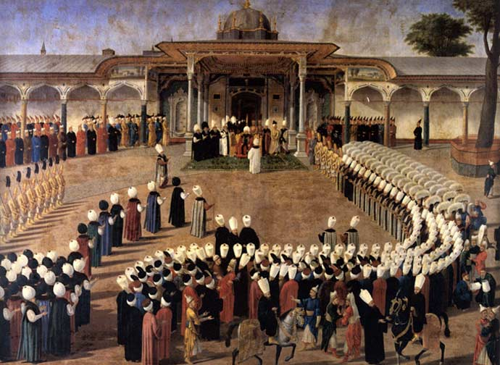
The Ottoman Empire was ruled by a single family that produced an unbroken line of sultans (rulers) from the 1300s until the early1900s. Under Suleiman—a sultan renowned for his sense of justice, his dedication to his people, his skills as a warrior, his understanding of Islam, and his artistic achievements—the Ottoman Empire experienced a golden age from 1520 to 1566. Europeans called Suleiman “the Magnificent,” but the Ottomans called Suleiman Kanuni, or “The Lawgiver,” because he established Ottoman law codes in order to create a unified system of justice, with Suleiman as the supreme authority.

Pause & Think!
“Citizens found guilty of consuming alcohol, the flesh of swine or other unclean foods shall be put to death. Citizens found guilty of worshipping any god other than Allah shall be put to death. Thieves found guilty of stealing should have their hands chopped off.” - Laws of Suleiman

Based on this quote, what religion was Suleiman’s system of justice based on? How did you get your answer?

II. How was Ottoman society organized?
Islam was the main religion in the Ottoman Empire, but Suleiman allowed freedom of religion. Non-Muslims were allowed to create their own communities, live in their own neighborhoods, and run their own schools. However, Suleiman did charge Christians and Jews a personal tax as payment for being allowed to practice their religion. Suleiman organized society according to four different categories, which were based on religion, occupation, and education.

In the heterogeneous Ottoman Empire (c. 1300–1923), a millet was an autonomous self-governing religious community, each organized under its own laws and headed by a religious leader, who was responsible to the central government for the fulfillment of millet responsibilities and duties, particularly those of paying taxes and maintaining internal security. In addition, each millet assumed responsibility for social and administrative functions not provided by the state, conducting affairs through a communal council without intervention from outside.

1) To what extent was the Ottoman Empire religiously tolerant? Why?

2) What is a millet?

