**OLMEC HEADS**

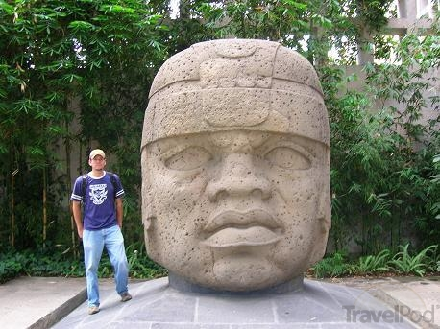

A. Why do you think these monuments were created? Give three possible reasons

B. Who could have ordered them to be created? (Think of the social pyramid)

D. The material used to create these Olmec heads (a type of stone called basalt) was located 60 miles away, and each head weighs between 10 to 20 tons. There were no beasts of burden (horses, oxen, etc.) to help with transportation. It is estimated that it would take 2,000 people to carry the colossal heads overland. What conditions must have been in place for these stone heads to have been created (think back to our elements of civilization)? Be specific.

**Additional Information on the Olmec Heads**

The basalt used to make the colossal heads came from the Tuxtla Mountains, about sixty miles due west of La Venta. According to Michael Coe, an archaeologist, the Olmec selected some of the big basalt boulders from the bottom of the lower slopes of the mountains to make these heads. Historians still do not know whether the heads were carved at the base of a mountain or transported back to the ceremonial platforms and carved there. Historians are also not sure how the Olmec transported basalt boulders weighing ten to twenty tons. About twenty-five miles from the base of the mountains, there are feeder streams that flow into the Coatzacoalcos River, near the mountains, and out to the Gulf of Mexico. The La Venta site is near another river, the Tonala River (Rio Tonala), which also flows into the Gulf.

What tools or technology did the Olmec use to carve the basalt into the stone heads? With no local hardware store available, they first needed to make a chisel of some sort. What could they use to make a rock-breaking chisel? What tools or technology did they use to transport the heads to the ceremonial platforms? There were no beasts of burden to help with transportation. It is estimated that it would take 2,000 people to carry the colossal heads overland.

**Do the colossal heads (including both what they might depict and the**

**process of mining, transporting, sculpting, and lifting involved) prove that Olmec society was as complex as other civilizations we have discussed (Mesopotamia, Egypt, Indus, China)?**

Directions: To answer this question, find proof that Olmec society fulfilled the following aspects of a complex society. Complete the chart and the questions below on a separate sheet of paper. There is no need to rewrite the chart- just number your proof!!!

|  |  |  |
| --- | --- | --- |
| **Aspects of a Complex Society** | **The ‘Proof” it existed in Olmec society**   * What artifacts exist * Use the reading, the textbook, and the information from the presentation. | |
| 1. labor specialization   * What kind of skills would have been necessary to create and move the heads? * Did the work require many specialized jobs? | |  |
| 2. Social stratification   * What kind of social and political organization might have been required? | |  |
| 3. Centralized government   * Did the work require the existence of a supreme ruler? | |  |
| 4. Surplus production of food | |  |
| 5. Dominant/organized religion | |  |
| 1. Monumental structures/ Public Works  * Irrigation, protective walls, plumbing, tombs, temple mounts, etc) | |  |

# The Olmec

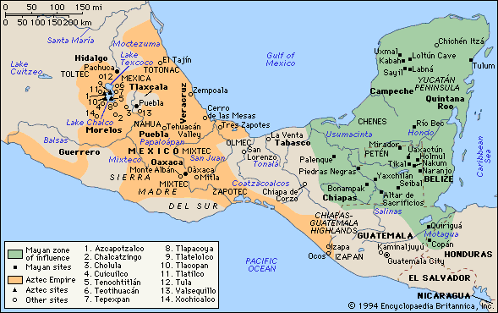The first signs of complex society in Mesoamerica are that of the Olmec civilization which was prominent in Mesoamerica from as early as 1500 BCE through 100 BCE, although there is evidence that the Olmec culture existed into the Common Era.

The Olmec heartland is an area on the south coast of the Gulf of Mexico. Over 170 Olmec monuments have been found within the area, and eighty percent of those occur at the three largest Olmec centers, La Venta, Tabasco (38%), San Lorenzo Tenochtitlan, Veracruz (30%), and Laguna de los Cerros, Veracruz (12%). Those three major Olmec centers are spaced from east to west across the domain so that each center could exploit, control, and provide a distinct set of natural resources valuable to the overall Olmec economy.

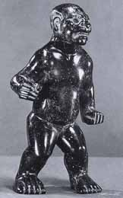The Olmec architecture at San Lorenzo, for example, includes public-ceremonial buildings which were most typically earthen platform mounds on which elite residences were built. The elite or aristocrats literally lived above the commoners. The houses of commoners were simple and made of mud and sticks. On these mounds or pyramids elaborate religious rituals involving priests and rulers impressed commoners. Rulers came to be associated with the gods through bloodletting and human sacrifice. Olmec gods had a dual nature (male/female or human/animal). Sculptures show rulers and shamans (priests/healer/ medicine men or women) able to transform themselves into powerful animals such as the Jaguar, shark or snake.

In the figurine the 'Standing figure of a Were-Jaguar' a Shaman is seen in the transformation process from man to Jaguar.

An important feature at the Olmec centers were **drainage systems.** Research at San Lorenzo suggests those systems were actually aqueducts used to provide drinking water to the different areas of the settlement. Some of the aqueduct stones, such as San Lorenzo Monument 52, were also monuments, indicating that the aqueduct system had a sacred character as well.

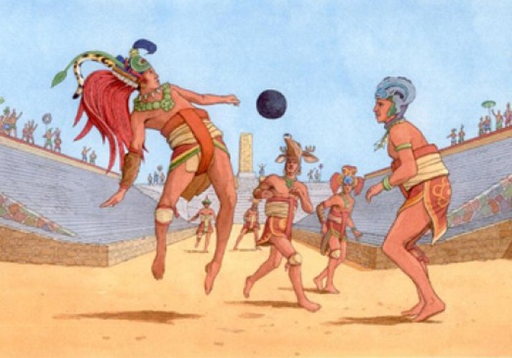The word "Olmec" also refers to the rubber balls used for their ancient ball game. Rubber ball games have great antiquity throughout the Americas, and the recent discovery of several rubber balls at the Olmec site of El Manati, near San Lorenzo, confirms that the game was played by the Olmec. The Olmec were perhaps the originators of the Mesoamerican ballgame.

Shamans and healers provided practical advice about the periodic rains essential to agricultural life. They directed the planning of urban centers to reflect astronomical observations and were responsible for developing a form of writing that may have influenced the Maya. From their close observation of the stars, they produced a calendar that was used to organize ritual life and agriculture.

It is not known with any clarity what happened to this culture. Their main center at San Lorenzo, was all but abandoned around 900 BC, and La Venta became the main city. Environmental changes may have been responsible for this move, with certain important rivers changing course. However, there is also some evidence suggestive of an invasion and destruction of Olmec artifacts around this time.

<http://www.crystalinks.com/olmec.html>

### **LEGACY**

The Olmecs influenced the civilizations they came into contact with across Mesoamerica, particularly in sculpture in ceramic and jade and objects featuring Olmec imagery have been found at Teopantecuanitlan, 650 km distant from the Olmec heartland. In addition, many deities featured in Olmec art and religion such as the sky-dragon (a sort of caiman creature with flaming eyebrows) and the feathered-snake god, would reappear in similar form in later religions. The snake-god especially, would be transformed into the major gods Kukulcan for the Maya and [**Quetzalcoatl**](http://www.ancient.eu/Quetzalcoatl/) for the Aztecs. This artistic and religious influence, along with the features of precisely aligned ceremonial precincts, monumental pyramids, sacrificial rituals and ball-courts, meant that all subsequent Mesoamerican cultures would owe a great deal to their mysterious forerunners, the Olmecs.

To what extent are the Olmec a Civilization?

|  |  |
| --- | --- |
|  |  |
|  | The photo shows a cylinder seal that was discovered at an Olmec site at San Andréas in Mexico. The image at right shows what would be printed when the seal is inked and rolled out. The bird appears to be "speaking" the markings at far right. Among the markings are symbols for kingship  and a calendar date, and researchers say they probably represent the name of an Olmec king. |
|  | The most well-known aspect of shamanism in Mesoamerican religion, and in the whole of Native American shamanism, is the ability to assume the powers of animals associated with the shaman. Such animals are called *nahuales*, and in Olmec art the most common of these is the jaguar. In a sense, the optimal spirit would have the spirituality and intellect of man and the ferocity and strength of the jaguar, these are all combined in the shaman and his jaguar *nahuale*. The Jaguar Child may exemplify this combination. This is a very common representation in Olmec art, and it often includes the slitted eyes and curved mouth pronounced in this close-up. |