Procopius: JUSTINIAN SUPPRESSES THE NIKA REVOLT, 532 CE

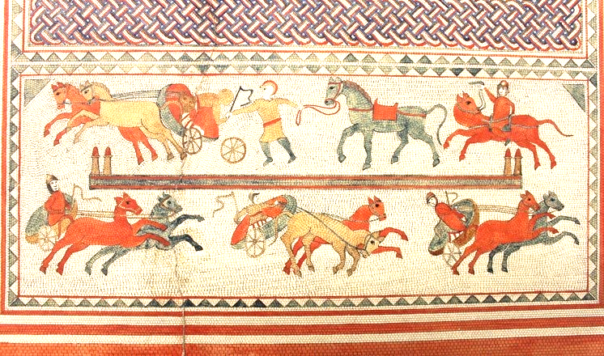
At this time [January 1, 532] a rebellion broke out unexpectedly in Byzantium among the populace, and, contrary to expectation, it proved to be a very serious affair, and ended in great harm to the people and to the senate, as the following account will show.
In every city the population has been divided for a long time past into the Blue and the Green factions; but within comparatively recent times it has come about that, for the sake of these names and the seats which the rival factions occupy in watching the [chariot races]... So there grows up in them against their fellow men a hostility which has no cause, and at no time does it cease or disappear...
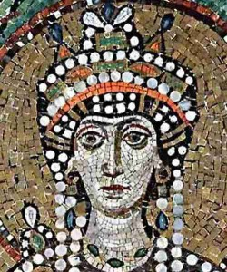
At this time the officers of the city administration in Byzantium were leading away to death some of rioters. But the members of the two factions conspiring together and declaring a truce with each other, seized the prisoners and then straightway entered the prison and released all those who were in jail. . . . Fire was set to the city as if it had fallen under the hand of an enemy. . . . The emperor and his consort [wife], with a few members of the senate shut themselves up in the palace and remained quietly there. Now the watch-word which the populace passed to one another was Nika [i.e., "Conquer"]. . . .
The emperor and his court were discussing as to whether it would be better for them if they remained or if they took to flight in the ships. And many opinions were expressed favoring either course. And the Empress Theodora also spoke to the following effect: "My opinion then is that the present time, above all others, is inopportune for flight, even though it bring safety. . . . For one who has been an emperor it is unendurable to be a fugitive. May I never be separated from this purple, and may I not live that day on which those who meet me shall not address me as mistress. If, now, it is your wish to save yourself, O Emperor, there is no difficulty. For we have much money, and there is the sea, here the boats. However consider whether it will not come about after you have been saved that you would gladly exchange that safety for death. For as for myself, I approve a certain ancient saying that royalty is a good burial-shroud." When the queen had spoken thus, all were filled with boldness, and, turning their thoughts towards resistance, they began to consider how they might be able to defend themselves if any hostile force should come against them. . . ..

Justinian orders his general Belisarius to execute the revolting citizens in the hippodrome
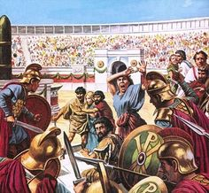
[The general] Belisarius, with difficulty and not without danger and great exertion, made his way over ground covered by ruins and half-burned buildings, and ascended to the stadium [where the revolting citizens had gathered]. . . . Concluding that he must go against the populace who had taken their stand in the hippodrome-a vast multitude crowding each other in great disorder-he drew his sword from its sheath and, commanding the others to do likewise, with a shout be advanced upon them at a run. But the populace, who were standing in a mass and not in order, at the sight of armored soldiers who had a great reputation for bravery and experience in war... beat a hasty retreat. . . There perished among the populace on that day more than thirty thousand. . . . The soldiers killed both [Hypatius and Pompeius, leaders of the revolt] on the following day and threw bodies into the sea. . . . This was the end of the insurrection in Byzantium.
from Procopius, History of the Wars, I, xxiv, translated by H.B. Dewing (New York: Macmillan, 1914), pp. 219-230, slightly abbridged and reprinted in Leon Barnard and Theodore B. Hodges, Readings in European History, (New York: Macmillan, 1958), 52-55

QUESTIONS
1) What occurred during the Nika Revolt? Summarize the events.

2) What does Theodora's speech (paragraph 6) tell us about her character? How does Procopius portray her?

3) What does the massacre of 30,000 citizens tell us about Justinian?

4) Source the document: purpose, intended audience, author, context.

