Napoleon Bonaparte

Origins

Early Career

Coup Emperor/Dictator

Military Success

Continental System

Battle of Trafalgar

Invasion of Russia (1812)

1st Exile to Elba

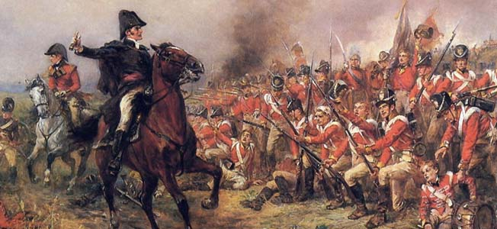
Battle of Waterloo (1815)

2nd Exile to St. Helena (1815-1821)

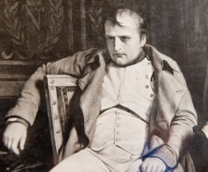
Legacy

Code of Napoleon

Nationalism

Revolutionary Ideas

