Napoleon's November Coup, 1799

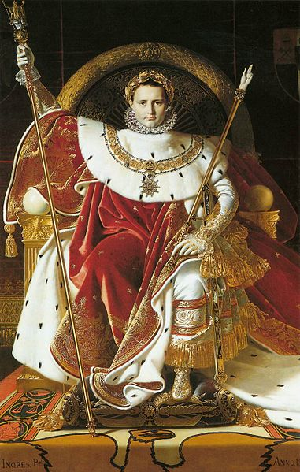
The coup of 1799 is generally taken to mark the end of the French Revolution and the beginning of Napoleon Bonaparte's dictatorship. The Corsican had returned from Egypt on October 9th. His success in evading the British confirmed the growing belief in Napoleon's 'star'.

The regime which Bonaparte was about to bring down was the Directory, a committee of five, which had been set up in 1795 after the fall of Robespierre. The government was bankrupt, while inflation, taxation and unemployment were soaring. The regime had lost control in much of the country, and there was virtual civil war in some areas.
Inside the Directory itself, one member was determined to introduce a new system. He and Napoleon agreed to work together. Abbes Sieyès [of "What is the Third Estate?" fame] totally underestimated the younger man in imagining that Bonaparte would tamely serve his purposes.
Action began when Sieyès announced the discovery of a Jacobin plot. The two assemblies of the government (the Council of Elders and Council of 500), alarmed, moved from central Paris and the dreaded Parisian mob to the former Royal palace at Saint-Cloud. To ensure their safety they put General Bonaparte in command of all troops in the capital and he moved 6,000 men into place around the palace. All members of the Directory were arrested or resigned.

The Directory was dead and the plotters' plan was that next day, November 10th, the assemblies should put a new executive in place, but the deputies [council members] irritatingly argued until Napoleon lost patience. He stumped in to the hall of the Elders and made a speech defending himself against charges of being a Caesar or a Cromwell. In fury at this intrusion, some of them pummeled him, bawling 'Outlaw!', 'Down with him!', and 'Kill, kill!'
The conspiracy was saved by Lucien Bonaparte, who came out and addressed the soldiers guarding the assembly. He told them that some deputies had terrorized the majority and tried to assassinate the general. The guards, suitably impressed, advanced to clear the palace. The deputies left in some haste, some by jumping from windows.
On December 13th the new constitution was formally proclaimed, with Napoleon as First Consul with full executive powers. Five years later he would be Emperor of the French [see image above].

QUESTIONS
1) According to this passage, how did Napoleon rise from successful general to emperor of France?

2) Do Napoleon's actions reflect the values of the French Revolution? Why, why not? Cite specific evidence from the passage.

3) Were Napoleon's actions justified given the condition France was in when he returned from Egypt?

4) What are the advantages of a single, all-powerful executive leader, in this case an emperor, compared to a large committee or council? What are the disadvantages?

