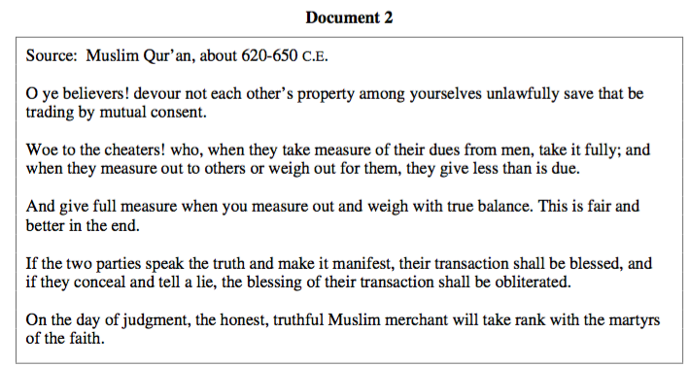
Document 2- Muslim Attitudes Toward Trade

QUESTIONS
1) What is Muhammed's view of trade in this document? Cite 3 specific pieces of evidence.

2) Based on the document, would you think merchants would be favorable to Islam? Why or why not?

Document 3-Muslim Attitudes Toward Trade
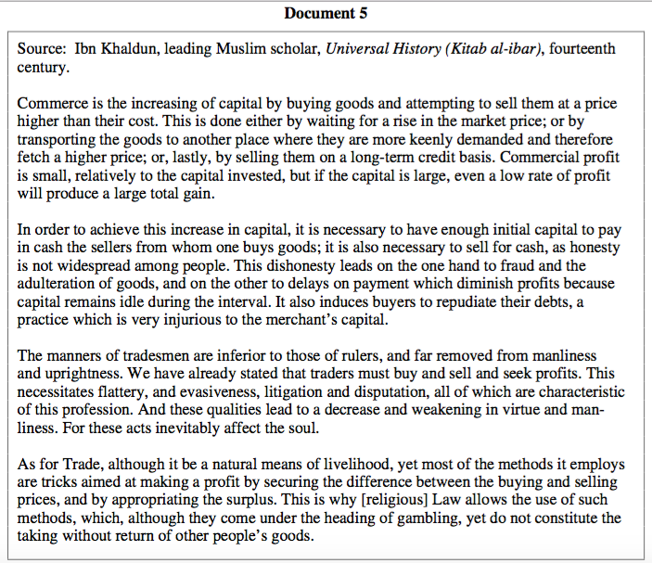

QUESTIONS
1) What is this Muslim scholar's view of tradesmen (merchants) and trade in general? Cite 3 specific pieces of evidence.

2) How does the last line ("This is why...other people's good.") seemingly contradict this Muslim scholar's view of trade and merchants?

