MUHAMMAD AND ISLAM ORIGINS

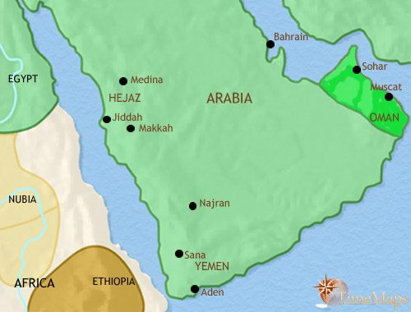
Born in Mecca, in western Arabia, Muhammad (ca. 570–632), last in the line of Judeo-Christian prophets, received his first revelation in 610 CE. Muslims believe that the word of God was revealed to him by the archangel Gabriel in Arabic, who said, “Recite in the name of thy Lord …” (Sura 96). These revelations were subsequently collected and codified as the Qur’an (literally “recitation” in Arabic), the Muslim holy book. As the source of Muslim faith and practice, the Qur’an describes the relationship between an almighty and all-knowing God and his creations. The Qur’an also maintains that all individuals are responsible for their actions, for which they will be judged by God, and so it provides guidelines for proper behavior within the framework of a just and equitable society.
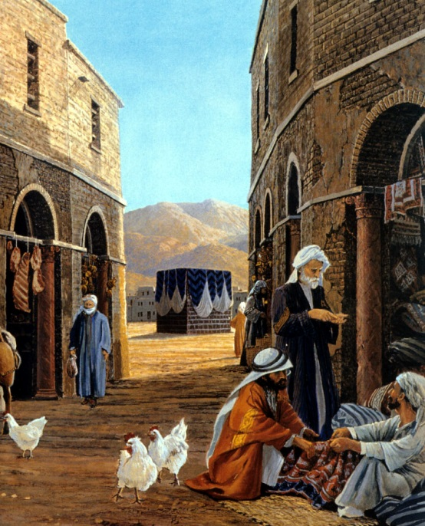
In the 7th century CE, Mecca was a prosperous city whose wealth and influence were based on the caravan trade and on the Ka’ba, a shrine and a place of pilgrimage housing the pagan deities then being worshipped by the Arabs. Muhammad’s message, heralding a new socio-religious order based on allegiance to one god—Allah—was unpopular among the leaders of Mecca, and they forced Muhammad and his followers to emigrate north to the oasis town Medina. This occurred in 622, the year of the hijra, or “emigration,” which marks the beginning of the Muslim calendar. In Medina, Muhammad continued to attract followers and, within a few years, Mecca had also largely embraced Islam. Upon his return to Mecca, one of the Prophet’s first acts was to cleanse the Ka’ba of its idols and rededicate the shrine to Allah.
Although Muhammad died in 632, his followers, led by a series of four caliphs (Arabic: khalifa, “successor”) known as the Rightly Guided, continued to spread the message of Islam. Under their command, the Arab armies carried the new faith and leadership from the Arabian Peninsula to the shores of the Mediterranean and to the eastern reaches of Iran. The Arabs conquered Syria, Palestine, and Egypt from the Byzantine empire, while Iraq and Iran, the heart of the Sasanian empire, succumbed to their forces. Here in these lands, Islam fostered the development of a religious, political, and cultural commonwealth and the creation of a global empire.
SKIP THIS SECTION AND ANSWER QUESTIONS
While the full formation of a distinctive Islamic artistic language took several centuries, the seeds were sown during the Prophet’s time. Because it is through writing that the Qur’an is transmitted, the Arabic script was first transformed and beautified in order that it might be worthy of divine revelation. Thus, calligraphy started to gain prominence, becoming essential also to Islamic ornament. In architecture, following the hijra, Muhammad’s house in Medina developed into a center for the Muslim community and became the prototype for the mosque, the Muslim sanctuary for God. The early structure, known as the hypostyle mosque, included a columned hall oriented toward Mecca and an adjacent courtyard surrounded by a colonnade. The call to prayer was given from a rooftop (later the minaret was developed for this purpose). Essential elements of the mosque were a minbar (pulpit) for the Friday sermon and a mihrab (prayer niche) set in the wall oriented toward Mecca.
Suzan Yalman
Department of Education, The Metropolitan Museum of Art
QUESTIONS
1) What is the Qu'ran? What does it provide Muslims?

2) What is the ka'ba? How did Muhammad change its worship by Muslims?

3) Why was Muhammad driven out of Mecca to Medina on the hijra?

4) Muhammad was a merchant from Mecca; what influence might this have on Islam's view of trade, money, etc.?

