Encomienda and Mita System

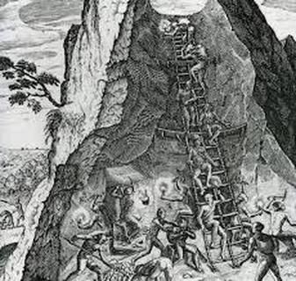

Mita System-forced labor system, often used Native Americans to work in silver and gold mines or public works such as roads and churches. Workers supposed to be paid a wage. Adapted from Incan model but without reciprocal relationship that it once had. Spanish kept local Native American leaders in place to organize labor, abuse and corruption common.

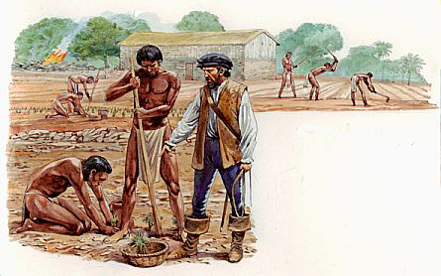

Encomienda System-encomiendas, land with Native Americans attached; Native Americans had to work for encomenderos (landowners) or pay taxes. Poor working conditions, border-line slavery, attached to the land further decimated Native American population.

