Name: ________________________ Date: _____________
Global History & Geography 9H

Aim:
Do Now: Independently, in the thought bubble below, write anything you can remember about Buddhism.
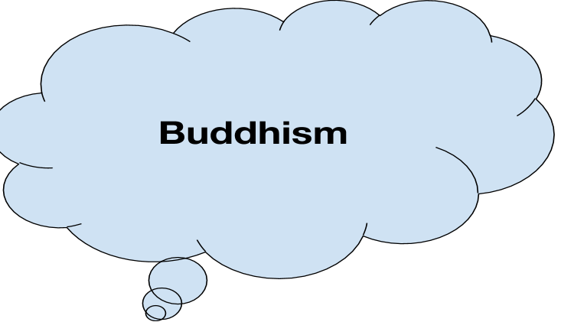
Directions: With your partner, select the three most important facts for your classmates to know about Buddhism, then share them with the class. Circle them.
The Maurya Empire

Origins:

Founder: Chandragupta Maurya-(320's BCE)

Arthashastra-

Ashoka
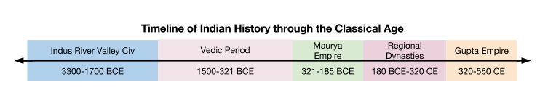THE BIRTH OF INDIA’S FIRST EMPIRE
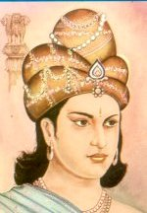
ASOKA (ASHOKA) THE GREAT
(304-232 BCE)
Once Asoka rose to the throne, he began an aggressive campaign to conquer the remainder of the subcontinent. The last major regions yet to be conquered were the Dravidian regions in the far south and the region of Kalinga in North India.
The conquest of Kalinga, which extended Mauryan rule to its farthest boundaries, seems to have been a tremendous shock to Asoka. War and conquest are always bloody and cruel, and the experience of mass death is often an experience that shakes people to their very souls. Asoka was so troubled by the conquest that he underwent a religious conversion to Buddhism.
The Buddhist way of life was a way out of Asoka's crisis. He converted to Buddhism and strove to achieve the Buddhist "middle way" between extremes. He became a vegetarian, renounced all warfare, and attempted to build a state based on Buddhist principles. First and foremost, the state would strive for nonviolence; in place of violence, the state would rule by "law" or "right".
Asoka, of course, could not put all of these reforms into practice. He found that some level of violence and retribution was necessary and declared as much. Although he made the laws less harsh, they still involved physical punishment and, in some cases, execution. Still, Asoka began a process of transformation in Indian society. Although he took the vows of Buddhism and even joined the order, he chose to remain active in the real world and exemplify his religion in his actions as king. He also demanded religious toleration; under Asoka, all competing religious systems were allowed to co-exist peacefully. The stunning ability of Indian culture to tolerate competing religions throughout its history begins with Asoka. Finally, although he could never really fully translate Buddhist ideals into government, he began a process of cultural transformation that would completely remake India. By the start of the Gupta dynasty, the bulk of Indian society had become vegetarian and no laws carried the death penalty.
His greatest achievement, however, was cultural. He was dedicated to his new religion and fervently patronized its expansion. Under Asoka, Buddhist monks were sent in every compass direction: to Burma, Tibet, Nepal, Persia, Mesopotamia, Syria, and Israel. The eastern missions were extremely successful; Buddhism spread very quickly from Nepal and Burma into Tibet and China where it was fervidly embraced. The western missions, however, were less successful. However, Buddhism left traces in Middle Eastern and even European culture. For instance, one of the Catholic saints of the Middle Ages and the Renaissance was Barlam, whose life is based on that of Siddhartha Gautama, the Buddha. Not only is this Catholic saint the Buddha, but one of the stories of Barlam is the conversion of a cruel king, Iosaphat; this king, in many ways, corresponds to Asoka, who is presented as intolerant and cruel before his conversion in the Indian epic, Asokavadana. So there is tantalizing evidence that Buddhism has had some influence on Christianity, though we are not quite sure to what extent. Finally, Asoka's zeal in spreading Buddhism beyond the borders of India ensured its survival, for when the Muslims defeated the Hindus and took control of India, Buddhism was destroyed as an organized religion in India.
Asoka was the last of the great kings of the Mauryan dynasty. His successors were less energetic and capable; in 184 BC, the last of the Mauryan kings was assassinated, and the first empire of India came to an end.

QUESTIONS FOR ANALYSIS AND DISCUSSION

- How did Asoka reflect Buddhism in the way he ruled?

- How did Asoka change India?

- How did Asoka’s influence spread past India? Why should we still talk about him today?

- Respond to the following question: What does the phrase “some level of violence and retribution is necessary” mean? Do you think this is true? Why or why not?

The Edicts of Ashoka
To make his Buddhist-based laws known to everyone in his empire, Ashoka had them inscribed on rocks and pillars that were placed all over modern-day India, Nepal, and Pakistan. As a result, these writing are known as Ashoka’s Rock and Pillar Edicts. They are the primary historical source for most of what we know about Ashoka and the period during which he ruled the Maurya Empire. To this day, only nineteen of the pillars survive, six of them with Ashoka’s lion symbol on the top. They average between 40 and 50 feet in height.

Ashoka’s Rock and Pillar Edicts
1  2  3  4  5  6  7  8  9  10  11  12  13  14  15  16  17  18  19  20  21  22  23  24  25  26  27  28  29  30  31  32  33  34  35  36  37  38  39  40 | All men are my children. What I desire for my own children, and I desire their welfare and happiness both in this world and the next, that I desire for all men.  [Y]our aim should be to act with impartiality [fairness; evenhandedness]. It is because of these things -- envy, anger, cruelty, hate, indifference, laziness or tiredness -- that such a thing does not happen. Therefore your aim should be: "May these things not be in me." And the root of this is non-anger and patience...Failure in duty on your part will not please me. But done properly, it will win you heaven and you will be discharging your debts to me.  Happiness in this world and the next is difficult to obtain without much love for the Dharma, much self-examination, much respect, much fear (of evil), and much enthusiasm. But through my instruction this regard for Dharma and love of Dharma has grown day by day, and will continue to grow. And my officers of high, low and middle rank are practicing and conforming to Dharma, and are capable of inspiring others to do the same. Mahamatras [Ashoka’s officials responsible for making sure Dharma was followed] in border areas are doing the same. And these are my instructions: to protect with Dharma, to make happiness through Dharma and to guard with Dharma.  [King Ashoka] honors both ascetics [religious people] and the householders of all religions […] By so doing, one's own religion benefits, and so do other religions, while doing otherwise harms one's own religion and the religions of others. Whoever praises his own religion, due to excessive devotion, and condemns others with the thought "Let me glorify my own religion," only harms his own religion. Therefore contact (between religions) is good. One should listen to and respect the doctrines professed by others.  Whatever good deeds have been done by me, those the people accept and those they follow. Therefore they have progressed and will continue to progress by being respectful to mother and father, respectful to elders, by courtesy to the aged and proper behavior towards Brahmans and ascetics, towards the poor and distressed, and even towards servants and employees.  There is no gift like the gift of the Dharma...One benefits in this world and gains great merit in the next by giving the gift of the Dharma.  Therefore this Dharma edict has been written to last long and that my sons, grandsons and great-grandsons might act in conformity with it for the welfare of the world. However, this is difficult to do without great exertion.

- What does “the Dharma” mean in this document?
__________________________________
__________________________________________________________________________________________

- How did Ashoka plan to spread “the Dharma?”
_______________________________________________________________________________________________________________________________________

- What is Ashoka’s policy on religions other than Buddhism?
_______________________________________________________________________________________________________________________________________

- How does Ashoka want the people in his empire to act?
_______________________________________________________________________________________________________________________________________

- According to Ashoka, why should people act the way he suggests?
_______________________________________________________________________________________________________________________________________

Using the documents that you read in class today, answer the following question:
How did the Mauryan Empire use their beliefs systems and philosophical ideas to gain, consolidate, and maintain power?

