Name: Date:
Global History 9H Mr. Lipari

The Study of History
All of history is derived from both experience and perspective. Every one of us has been impacted by events in our lives, which in turn imbed certain biases. Therefore, completely objective description of events is nearly impossible. It is the historian's duty to cut through these biases and find the objective facts hidden beneath; to analyze and connect such facts and details; and to provide a rationale for their occurrence.

Below are two translations of an original quote from the Roman historian Livy, explaining the importance of studying history (see bottom of page 2 for original Latin). While this may not persuade you that the Neolithic Revolution is the most fascinating event in human history, carefully read the two translations below and answer the questions:
Translation A
The study of history is the best medicine for a sick mind; for in history you have a record of the infinite variety of human experience plainly set out for all to see; and in that record you can find for yourself and your country both examples and warnings: fine things to take as models, base [immoral] things, rotten through and through, to avoid.

Translation B
This [the study of history] is especially beneficial and profitable in learning, as you can consider all the examples and lessons placed upon the illustrious monument of history; from there you may take for you and your county lessons to imitate; from there you may avoid foul undertakings and horrible destruction.

1) What is different between the two translations? What is similar?

2) What do you think can account for these differences?

3) Why is noting these differences important? How does this relate to the larger study of history and its understanding?

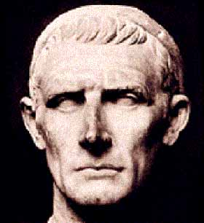
Titus Livius: 59 BCE-17 CE
Original Latin:
Hoc illud est praecipue in cognitione rerum salubre ac frugiferum, omnis te exempli documenta in inlustri posita monumento intueri; inde tibi tuaeque rei publicae quod imitere capias, inde foedum inceptu foedum exitu quod vites.

