PRIMARY SOURCE: THE TURKISH LETTERS, 1555 CE-1562 CE by Ogier Ghiselin de Busbecq (European diplomat)
SECTION 1
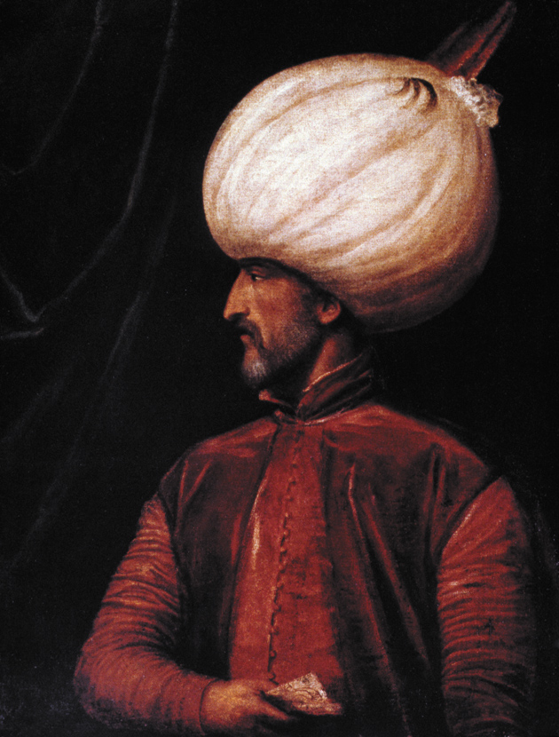
On his [Sultan Suleiman I’s] arrival we were admitted to an audience... The Sultan was seated on a very low ottoman, not more than a foot from the ground, which was covered with a quantity of costly rugs and cushions of exquisite workmanship; near him lay his bow and arrows. His air, as I said, was by no means gracious, and his face wore a stern, though dignified, expression...
The Sultan’s hall was crowded with people, among whom were several officers of high rank. Besides these there were all the troopers of the Imperial guard and a large force of Janissaries; but there was not in all that great assembly a single man who owed his position to aught save his valor and his merit. No distinction is attached to birth among the Turks; the deference [respect] to be paid to a man is measured by the position he holds in the public service. There is no fighting for precedence [superiority]; a man’s place is marked out by the duties he discharges.
In making his appointments the Sultan pays no regard to any pretensions on the score of wealth or rank, nor does he take into consideration recommendations or popularity; he considers each case on its own merits, and examines carefully into the character, ability, and disposition of the man whose promotion is in question. It is by merit that men rise in the service, a system which ensures that posts should only be assigned to the competent. Each man in Turkey carries in his own hand his ancestry and his position in life, which he may make or mar as he will. Those who receive the highest offices from the Sultan are for the most part the sons of shepherds or herdsmen, and so far from being ashamed of their parentage, they actually glory in it, and consider it a matter of boasting that they owe nothing to the accident of birth; for they do not believe that high qualities are either natural or hereditary, nor do they think that they can be handed down from father to son, but that they are partly the gift of God, and partly the result of good training, great industry, and unwearied zeal....
1) What sources of Ottoman political authority are present in Busbecq’s account?

2) Why is Busbecq so impressed with the Janissaries?
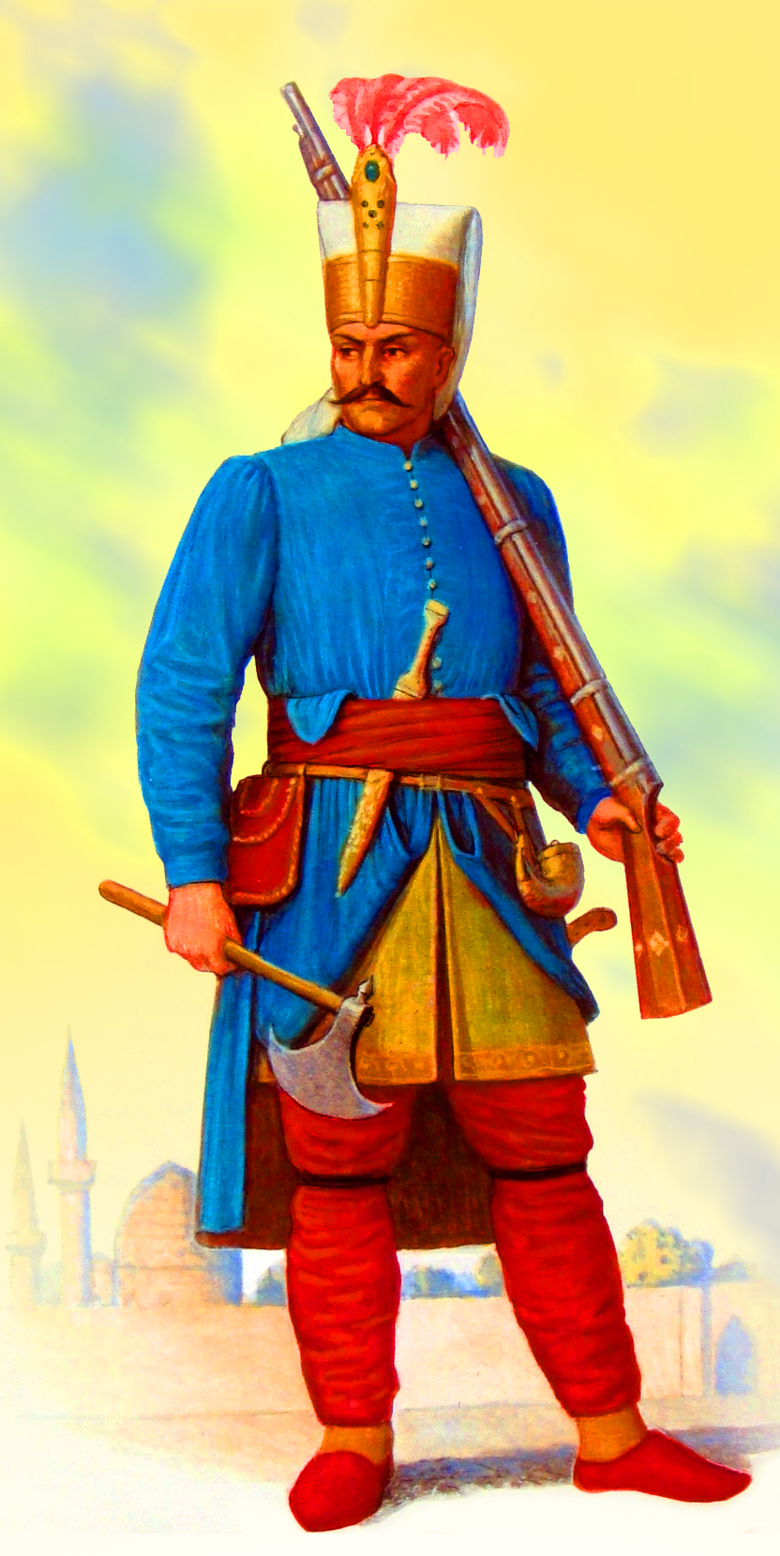
SECTION 2
Among the Turks, therefore, honors, high posts, and judgeships are the rewards of great ability and good service. If a man be dishonest, or lazy, or careless, he remains at the bottom of the ladder, an object of contempt [disgust]; for such qualities there are no honors in Turkey! This is the reason that they are successful in their undertakings, that they lord it over others, and are daily extending the bounds of their empire. These are not our ideas, with us [Europeans] there is no opening left for merit; birth is the standard for everything; the prestige of birth is the sole key to advancement in the public service....
Take your stand by my side, and look at the sea of turbaned heads, each wrapped in twisted folds of the whitest silk; look at those marvelously handsome dresses of every kind and every color; time would fail me to tell how all around is glittering with gold, with silver, with purple, with silk, and with velvet; words cannot convey an adequate idea of that strange and wondrous sight: it was the most beautiful spectacle I ever saw.
With all this luxury great simplicity and economy are combined; every man’s dress, whatever his position may be, is of the same pattern; no fringes or useless points are sewn on, as is the case with us, appendages which cost a great deal of money, and are worn out in three days.... I was greatly struck with the silence and order that prevailed in this great crowd. There were no cries, no hum of voices, the usual accompaniments of a motley gathering, neither was there any jostling; without the slightest disturbance each man took his proper place according to his rank.
On leaving the assembly we had a fresh treat in the sight of the household cavalry returning to their quarters; the men were mounted on splendid horses, excellently groomed, and gorgeously accoutered [outfitted]. And so we left the royal presence, taking with us but little hope of a successful issue to our embassy.
1) How does Busbecq's account portray the Janissaries? How are their described?

2) How are the Janiessaries different from what Busbecq knows in Europe?

SECTION 3
The Turkish monarch going to war takes with him over 40,000 camels and nearly as many baggage mules, of which a great part, when he is invading Persia, are loaded with rice and other kinds of grain. These mules and camels also serve to carry tents and armour, and likewise tools and munitions for the campaign.... The invading army carefully abstains from encroaching on its magazines [supplies] at the outset... Then the Sultan’s magazines are opened, and a ration just sufficient to sustain life is daily weighed out to the Janissaries and other troops of the royal household. The rest of the army are badly off, unless they have provided some supplies at their own expense.
From this you will see that it is the patience, self- denial, and thrift of the Turkish soldier that enable him to face the most trying circumstances, and come safely out of the dangers that surround him. What a contrast to our men! Christian soldiers on a campaign refuse to put up with their ordinary food, and call for thrushes, beccaficos [small bird], and such like dainty dishes! If these are not supplied they grow mutinous and work their own ruin; and, if they are supplied, they are ruined all the same. The only obstacle is Persia [the Safavid empire], whose position on his rear forces the invader to take precautions. The fear of Persia gives us a respite, but it is only for a time. When he has secured himself in that quarter, he will fall upon us with all the resources of the East. How ill prepared we are to meet such an attack it is not for me to say.
The sons of Turkish Sultans are in the most wretched position in the world, for, as soon as one of them succeeds his father, the rest are doomed to certain death. The Turk can endure no rival to the throne, and, indeed, the conduct of the Janissaries renders it impossible for the new Sultan to spare his brothers; for if one of them survives, the Janissaries are forever asking largesses. If these are refused, forthwith the cry is heard, ‘Long live the brother!’ ‘God preserve the brother!’ — a tolerably broad hint that they intend to place him on the throne. So that the Turkish Sultans are compelled to celebrate their succession by imbruing [staining] their hands in the blood of their nearest relatives. .
1) Shortly after Suleiman’s reign, the Ottoman Empire began to enter a period of decline. What in Busbecq’s account points to future problems for the Ottoman state?

2) Why have the Ottomans not yet conquered Europe, according to Busbecq? How do they go to war?

Final Question: How do you think Busbecq’s outsider status shaped his perceptions of Ottoman political and military life? To what extent does his role as a foreigner enhance or undermine the usefulness of his account for historians?

