Latin American Revolutions Notes

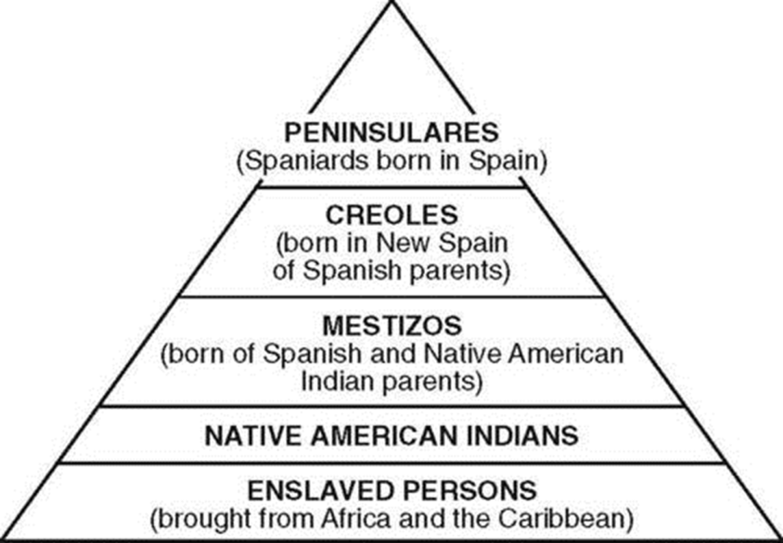
Casta System-determined job, taxes, status in society, based on racial purity

Influence of Catholic Church-very conservative, controlled everyday life for most Latin Americans, immensely powerful

CAUSES
Latin American Colonies-paid 20% tax on all goods, not allowed to govern themselves, nor build factories or advanced tech, had to purchase goods from Spain or Portugal. EXIST SOLELY FOR BENEFIT OF SPAIN/PORTUGAL

Peninsulares-.1% of population, ran the colonies as governors and administrators, part of church hierarchy as well

Creoles-around 20% of the population, white but born in the Spanish colonies. Desired political power and freedom for themselves, care about property rights

Mestizos-30% of population, mixed whites/Native Americans, also sought political rights and some form of equality, want communal land

Revolutions Began 1808

Napoleon Invaded Spain+Portugal, replaced their kings w/his brother->
Trade restrictions relaxed...

Latin American colonies taste freedom, some revolt because new Spanish king has liberal constitution created (anti-Catholic church), others see opportunity for freedom and political rights

1808-Mexico Revolted, under leadership of Father Miguel Hidalgo (a creole educated in Enlightenment values), used religion to motivate the lower classes (mestizos and mulattos), while creoles initially joined revolution but later betrayed Hidalgo for fear of losing power
Eventually Hidalgo was executed, creoles took control of revolution
1820-Mexican Wins Independence, rebel General Augustin Iturbide fought and defeated Spanish forces (after new constitution of Spain reduced power of the church and angered everybody in Mexico), became dictator of Mexico, thus beginning a string of dictators in Mexican history.

In 1814, original king of Spain returned, attempted to assert power again....and the fight for independence began elsewhere…

Simon Bolivar- the George Washington of South America
Helps unite various racial classes in fight against Spain
Ultimately fails in attempt to create and hold together Gran Columbia (modern-day Venezuela, Ecuador, Panama and Columbia) and died in exile, but achieved independence and abolished slavery in areas under his control.
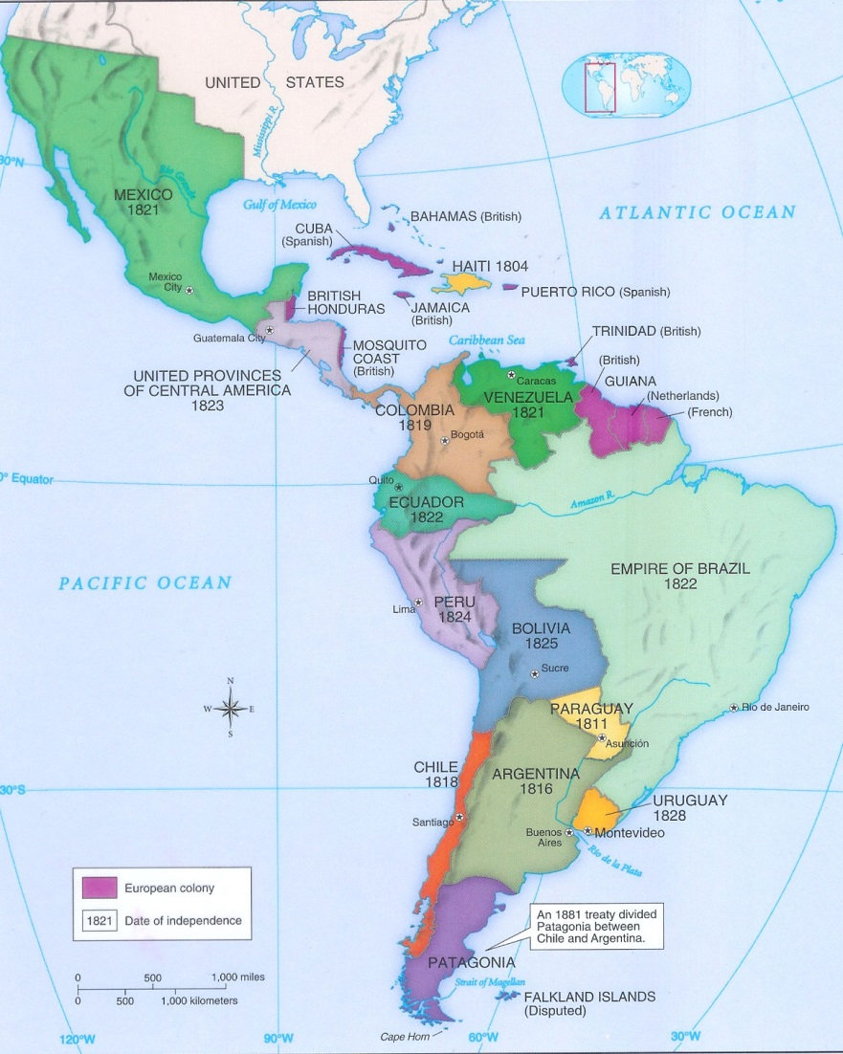

Results-
- By 1830, nearly all of Latin American was free from Spanish and Portuguese rule

- Catholic Church remained in power in most places

3) Long struggle between liberal reformers and conservatives would define Latin American for the next century and a half

(Freedom of religion vs. Catholicism, keep casta system or abolish it, strong central gov. vs. individual rights)

4) Peninsulares gone but Creoles replace them as the ruling class, slavery abolished in most former Spanish colonies, remained in other former colonies (Brazil)

Brazil super-short summary: son of Portuguese king takes control 1821 (w/father's approval), no violence, became constitutional monarch, kept slavery and status quo in society

REMEMBER: WHO IS LEADING THE REVOLUTION MATTERS

