Latin America Society:

Revolutionary ideals traveled beyond Saint-Domingue to the Spanish and Portuguese colonies in the Americas. Though governed by peninsulares, the Iberian colonies all had a large wealthy and powerful class of Euro-American, creoles. In 1800 the peninsulares numbered about 30,000 and the creole population was 3.5 million. The Iberian colonies also had a large population- about 10 million in all-of less privileged classes. Black slaves formed a majority in Brazil, but elsewhere indigenous peoples and individuals of mixed ancestry such a mestizos and mulattoes were most numerous.
- Describe the social classes in Latin America.

- Why did the Creoles benefit greatly throughout the 18th century?

- What were the Creoles grievances?

- Who did the revolutionaries look to as an example?
Creoles benefited greatly during the eighteenth century as they established plantations and ranches in the colonies and participated in rapidly expanding trade with Spain and Portugal. Yet the creoles also had grievances. Like British colonists in North America, the creoles resented administrative control and economic regulations imposed by the Iberian powers. They drew inspiration from Enlightenment political thought and occasionally took part in tax revolts and popular uprisings. The creoles desired neither social reform like that promoted by Robespierre nor the establishment of an egalitarian society like Haiti. Basically, they sought to displaces the peninsulares but retain their privileged position in society: political independence of the model of the United States in North America struck them as an attractive alternative to colonial status. Between 1810 and 1825, creoles led movements that brought independence to all Spanish colonies in the Americas- except Cuba and Puerto Rico-and established creole-dominated republics.
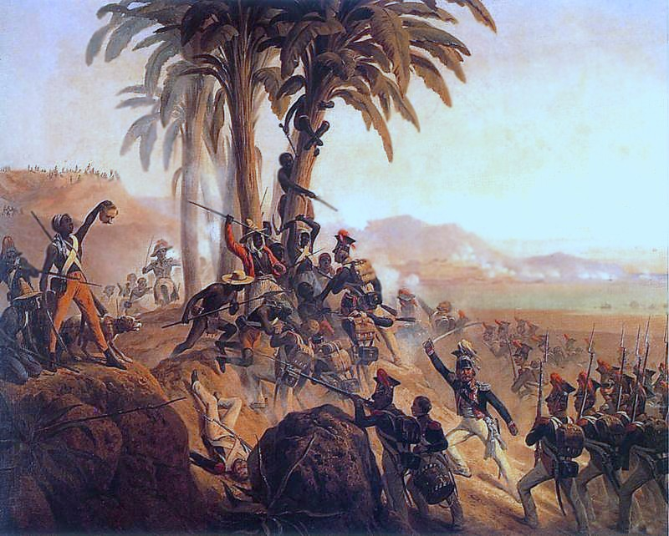
Mexican Independence

The struggle for independence began in the wake of Napoleon’s invasion of Spain and Portugal, which weakened royal authority in the Iberian colonies. By 1810, revolts against Spanish rule had broken out in Argentina, Venezulea and Mexico. The most serious was a peasant rebellion in Mexico led by a parish priest, Miguel Hidalgo y Costilla. He rallied indigenous peoples and mestizos against colonial rule. Many contemporaries viewed Hidalgo’s movement for independence from Spanish rule as social and economic warfare by the masses against the elites of Mexican society, particularly since he rallied people to his cause by invoking the name of the popular and venerated Virgin of Guadalupe and by calling for the death of Spaniards. Conservative creoles soon captured Hidalgo and executed him, but his rebellion continued to flare for three years after his death. Hidalgo became the symbol of Mexican independence and the day on which he proclaimed his revolt- 16 September 1810 is Mexico’s principal national holiday.
Colonial rule came to an end in 1821, when the creole general Augustin de Iturbide declared independence from Spain. In the following year, he declared himself emperor of Mexico; neither Iturbide nor his empire survived for long. Though an able general, Iturbide was an incompetent administrator and in 1823 creole elites deposed him and established a republic. Two years later the southern regions of the Mexican empire declared their own independence. They formed a Central American Federation until 1838, when they split into the independent states of Guatemala, El Salvador, Honduras, Nicaragua, and Costa Rica.
- How did the struggle for Mexican independence begin?

- Where did revolts break out?

- Who was the key leader in the Mexican Revolution? Describe his occupation, as well as his beliefs and goals.

- Who did he use to gain support? Why is this person significant?

- To what extent was the Mexican Revolution successful?

Document A
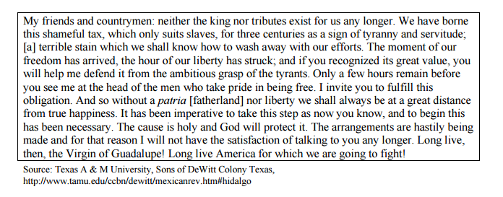
Document B

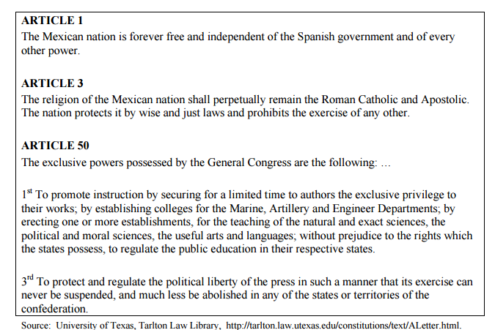

Document B

South American Independence
In South America, creole elites such as Simon Bolivar led the movement for independence. Born in Caracas (in modern Venezuela), Bolivar was a fervent republican steeped in Enlightenment ideas about popular sovereignty. Inspired by the example of George Washington, he took up arms against Spanish rule in 1811. In the early days of his struggle, Bolivar experienced many reversals and twice went into exile. In 1819, however, he assembled an army that surprised and crushed the Spanish army in Colombia. Later, he campaigned in Venezuela, Ecuador and Peru. He coordinated with Jose de San Martin in Argentina and Bernardo Higgins in Chile. By 1825 creole forces had overcome Spanish armies and deposed Spanish rulers throughout South America.
Bolivars goal was to weld the former Spanish colonies of South America into a great confederation like the United States in North America. During the 1820’s, independent Venezuela, Colombia and Ecuador formed a republic called Gran Colombia and Bolivar attempted to bring Peru, and Bolivia into the confederation. By 1830, however strong political and regional differences had undermined Gran Colombia. As the confederation disintegrated, a bitterly disappointed Bolivar pronounced South America “ungovernable” and lamented that “those who have served the revolution have plowed the sea”. Shortly after the breakup of Gran Colombia, Bolivar died of tuberculosis while enroute to self-imposed exile in Europe.
- How did the struggle for South American independence begin?

- Where did revolts break out?

- Who was the key leader in the Mexican Revolution? Describe his occupation, as well as his beliefs and goals.

- Who did he use to gain support?

- To what extent was the South American Revolution successful?

Document C
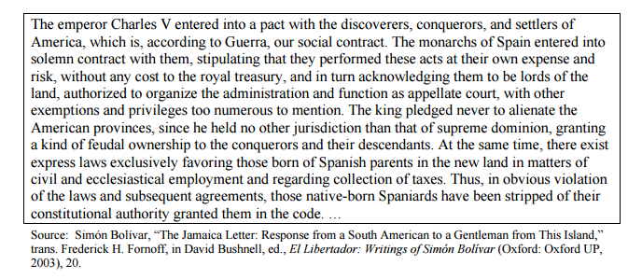
Document D

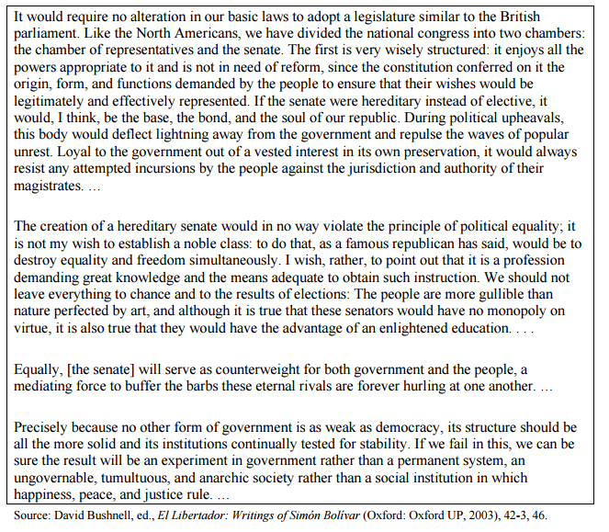

Brazilian Independence
Independence came to Portuguese Brazil at the same time as to the Spanish colonies but by a different process. When Napoleon invaded Portugal in 1807, the royal court fled to Lisbon and established a government in exile in Rio de Janeiro. In 1821, the king returned to Portugal, leaving his son Pedro in Brazil as regent. The next year Brazilian creoles called for independence from Portugal and Pedro agreed to their demands. When the Portuguese parliament tried to curtail his power, Pedro declared Brazil’s independence and accepted appointment as Emperor Pedro I.
Although Brazil achieved independence as a monarchy rather than a republic, creole elites dominated Brazilian society just as they did in former Spanish colonies. Indeed, independence brought little social change in Latin America. The peninsulares restored to Europe, but Latin American society remained as rigidly stratified as it had been in 1800. The newly independent states granted military authority to local charismatic strongmen known as caudillos, allied with creole elites. The new states also permitted the continuation of slavery, confirmed the wealthy and authority of the Roman Catholic Church, and repressed lower orders.

- How did the struggle for Brazilian independence begin?

- Was there a revolt, or an exchange of power? Describe the scenario.

- Who was the key leader in the Brazilian Revolution? Describe his occupation, as well as his beliefs and goals.

- To what extent did life change after becoming independent?

- To what extent was the South American Revolution successful?

Document E

In this account, Father Belchior Pinheira de Oliveira, a confidant of Prince Pedro, describes the exact moment of the declaration of independence, just after the prince has received the Cortes’ demand that he return.
Accompanied by me, Cordeiro, Bregaro, Carlota, and others, D. Pedro silently walked toward our horses at the side of the road. Suddenly, he halted in the middle of the road and said to me, “Father Belchior, they asked for it and they will get it. The Côrtes is persecuting me and calling me an adolescent and a Brazilian. Well, now let them see their adolescent in action. From today on our relations with them are finished. I want nothing more from the Portuguese government, and I proclaim Brazil forevermore separated from Portugal.”
With enthusiasm we immediately answered, “Long live liberty! Long live an independent Brazil! Long live D. Pedro!”
The Prince turned to his adjutant and said, “Tell my guard that I have just declared the complete independence of Brazil. We are free from Portugal.”
Lieutenant Canto e Melo rode toward a market where most of the soldiers of the guard remained. He returned to the Prince with them shouting enthusiastically in favor of an independent and separate Brazil, D. Pedro, and the Catholic Religion.
D. Pedro before the guard said, ‘The Portuguese Côrtes wants to enslave and to persecute us. Henceforth our relations are broken. Not one tie unites us!” (Burns 199)

