Hagia Sophia | Justinian's Code
Conquest
Legacy of Rome?
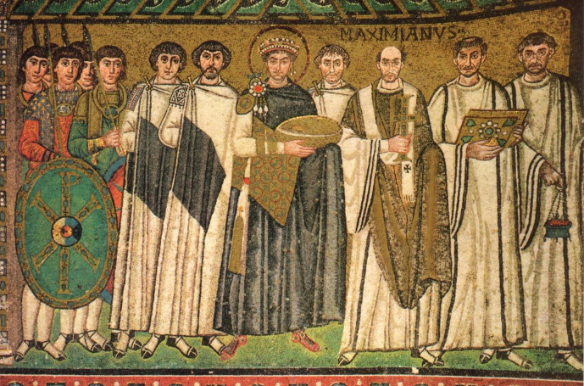
Justinian

