Corpus Iuris Civilis (Justinian's Code), 6th Century CE
The Digest: Prologue
The Emperor Caesar, Flavius, Justinianus, Pious, Fortunate, Renowned, Conqueror, and Triumpher, Ever Augustus, to Tribonianus His Quaestor., Greeting:
With the aid of God governing Our Empire which was delivered to Us by His Celestial Majesty [God]...
We have found the entire arrangement of the law which has come down to us from the foundation of the City of Rome and the times of Romulus, to be so confused that it is extended to an infinite length and is not within the grasp of human capacity; and hence We were first inspired to begin by examining what had been enacted by former most venerated princes, to correct their constitutions, and make them more easily understood; to the end that being included in a single Code, and having had removed all that is superfluous [extra]... they may afford to all men the ready assistance of true meaning.
***

Laws of Justinian (529-534CE)
Besides the Hagia Sophia the other major accomplishment of the Roman’s (of Byzantine Empire) during the reign of Justinian was the Corpus Juris Civilis (Justinian’s Code). Which took centuries of built up Roman law and codified/standardized it for the empire. It was a massive undertaking. Below are a few of the laws which reference the Byzantine attitudes toward Jews.

C.J., 1.5.12 Heretics are all such as do not belong to the Catholic faith including Jews. They are not to hold any office; or follow profession of law. Heavy penalties for responsibility with evasion.

C.J., 1,5.13, Orthodox children not to be disinherited by Jewish parents.

C.J, 1.5.17, Complete destruction of Samaritan synagogues ordered.

C.J, 1.3.54, No Jew to possess Christian slaves, or slaves desiring to become Christian.

C.J., 1.10.2, No Jew to own a Christian slave.

C.J., 1.9.2, addressed to the Jews. Sabbath not to be disturbed.
From The Digest of Justinian, C. H. Monro, ed. (Cambridge, Mass.: Cambridge Unversity Press, 1904).

QUESTIONS
1) Why is Justinian having a new law code created?

2) How does a universal law code help to unify an empire?

3) What is the official faith of the Byzantine Empire?

4) What do these laws say about the level of tolerance shown to those who don’t practice the official religion?

Excerpts from Justinian's Code:
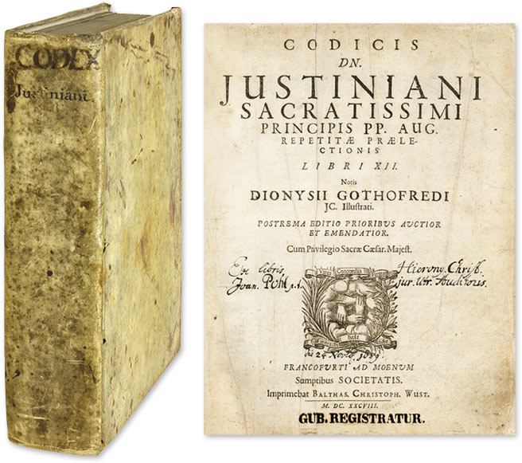
Justice is the set and constant purpose which gives to every man his due. jurisprudence is the knowledge of things divine and human, the science of the just and the unjust....
The precepts of the law are these: to live honestly, to injure no one, and to give every man his due. The study of law consists of two branches, law public and law private. The former relates to the welfare of the Roman State; the latter to the advantage of the individual citizen. Of private law then we may say that it is of threefold origin, being collected from the precepts of nature, from those of the law of nations, or from those of the civil law of Rome...
The civil law of Rome, and the law of all nations, differ from each other thus. The laws of every people governed by statutes and customs are partly peculiar to itself, partly common to all mankind. Those rules which a state enacts for its own members are peculiar to itself, and are called civil law: those rules prescribed by natural reason for all men are observed by all people alike, and are called the law of nations. Thus the laws of the Roman people are partly peculiar to itself, partly common to all nations; a distinction of which we shall take notice as occasion offers....

4) Why are laws important to the Byzantines? What do they provide?

5) How does the author divide the law? What are the differences between the two kinds of law he describes?

