John Locke on Natural Rights
“Reason,” Locke declared, “teaches all Mankind... that being all equal and independent, no one ought to harm another in his Life, Health, Liberty, or Possessions.” Locke imagined a rule of law: “have a standing Rule to live by, common to every one of that Society, and made by the Legislative Power erected in it; A freedom to follow my own Will in all things, where the Rule prescribes not; and not to be subject to the inconstant, uncertain, unknown, arbitrary [random] will of another Man." And that the government's power "has its origin only from compact, and agreement, and the mutual consent of those who make up the community . . .”
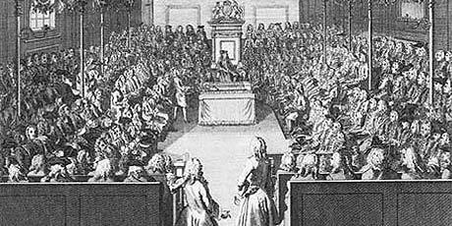

QUESTIONS
1) Where have you heard the terms similar to the phrase "life, health, liberty, and property" before?

2) What is the purpose of law according to Locke?

3) Where does the government enforcing these laws derive its power from?

