THE INDUSTRIAL REVOLUTION

Early Industrial Revolution

Flying shuttle
Spinning Jenny

Water Frame

Textile Mills powered by...

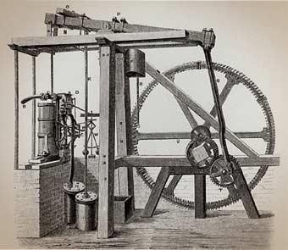
Causes of Industrial Revolution

Use of COAL

Steam Engine (2 designs)

1.

2.

Why important?

Why England?

High Wages

Lack of Invasions

Colonies

Property Rights

Coal Deposits

Iron and Steel Production

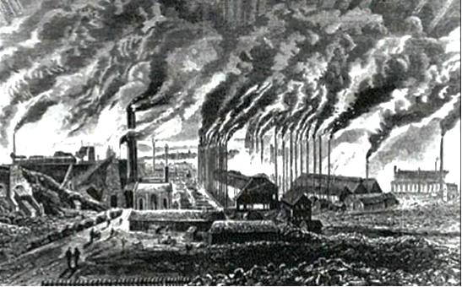

Factory System

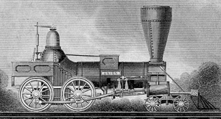
Transportation

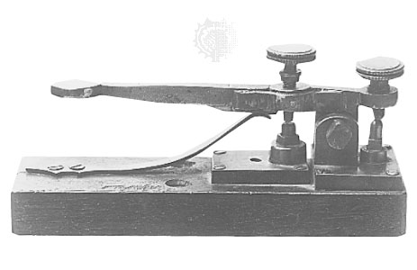
Communication

Imperialism

Colonies

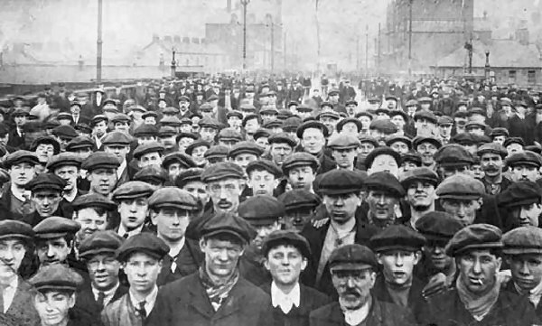
Impact

Daily Life

Religion

Science

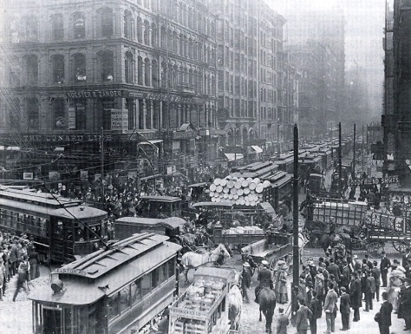
Urban Growth

Responses

Romanticism

Socialism/Communism

Liberalism

Feminism

Luddite Movement

