Indus River Valley
Read the documents below. Answer the questions that follow.
Document 1
Archaeologists have found ruins of many cities along the Indus River. They date these cities back to about 2000 B.C.E. The largest cities were Mohenjo-Daro and Harappa. These cities were laid out along a precise grid with a fortified citadel and a separate section for residential housing. The bricks used to construct the cities' buildings were remarkably uniform in size for an ancient civilization. Engineers provided indoor plumbing and sewer systems so that most houses had private bathrooms and toilets. A great bath provided some form of public or ritualistic bathing.
Source: Bech, Black, Krieger, Naylor, Shabaka, World History: Patterns of Interaction, McDougal Littell, 1999 (adapted and edited)
- What made the cities along the Indus River unusual for their time?
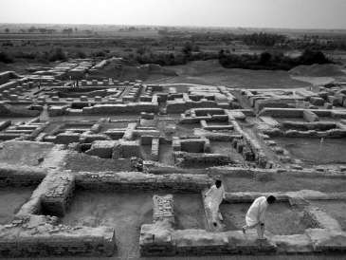

- How does the photograph (left) of Mohenjo-Daro support Document 1?

- What impact might this urban planning have had on later civilizations? How was such uniform construction possible?

Document 2 The Indus people did not engrave inscriptions on stones or place papyrus scrolls in the tombs of their dead; all we know of their writing is derived from the simple inscriptions on their seals. Several efforts have been made to decipher the Indus seals, but none have truly succeeded this far; there is some notion that these seals could have been used as markers in trade situations, or that some may have represented family names. What we do know of this civilization comes from the intense archaeological excavation of the area. Anthropologists do know that these cities were highly developed for their period in history; the structure of their cities were so far advanced that it was not surpassed until the late nineteenth century in Europe. The genius behind the advanced architecture of the Indus civilization carried over into a thriving agricultural and trade based economy. The Indus people used the plentiful rivers surrounding them much to their advantage, the Indus the most spectacular of the three rivers. From every crop that a farmer grew, a large portion of it had to be paid into public granaries. At the Mohenjo-daro site, there was a high loading platform above a lower spot intended for carts where the farmers would dump their grain. It is assumed that this cart was small and powered by an ox, similar to those used in the area today. Terracotta models of bull driven carts have been excavated from the Mohenjo-daro site, and it appears that these carts have changed very little over some 4000 years.
Aside from the subsistence of agriculture and hunting, the Indus people supported themselves by trading goods. Through trade, the Indus Civilization expanded its culture, coming into regular contacts with faraway lands. The long coastline and many rivers provided the people of the Indus territories with consistent trafficking by water. Archaeologists have turned up imports including gold from southern India, copper from Afghanistan, jade like fuchsite probably from southern India, and turquoise from Iran. Trade with Mesopotamia has been noted, as Indus pottery has been discovered in the ancient city of Tell Asmar. A number of typical Indus seals have also been found in Sumer, seals dating back to between 2300 and 2000 BC. The finding of Indus seals in Mesopotamia suggests that people of Indus may have resided in this territory; possibly merchants who were keeping up a constant trade with the Mesopotamian people (cotton was a staple export of Indus, and could have been the crop that brought these two civilizations into contact).
Source: Adapted from Economics of the Indus Valley Civilization by Chad Greenwood

Based on Document 2, answer the questions below.
- What is known about the writing of the Indus River Valley? How do we know about the people of the Indus River Valley?

- In what two ways did the people of the Indus River Valley make a living?

- How do we know that the people of the Indus River Valley traded with the rest of the ancient world?

Document 3
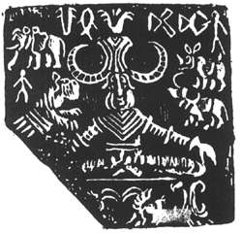
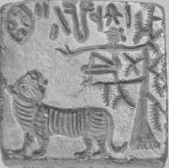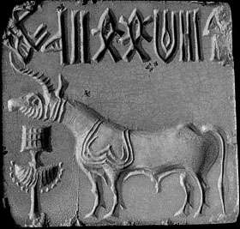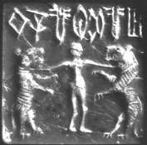
1) What can you speculate about the Indus Valley based on the inscriptions and pictures on the seals?

Document 4
The Harappan (or Indus) civilization was the largest — but least known — of the first great urban cultures that also included Egypt and Mesopotamia. Like their contemporaries, the Harappans, named for one of their largest cities, lived next to rivers owing their livelihoods to the fertility of annually watered lands. “We reconstructed the dynamic landscape of the plain where the Indus civilization developed 5200 years ago, built its cities, and slowly disintegrated between 3900 and 3000 years ago,” said Liviu Giosan, a geologist at Woods Hole Oceanographic Institution and lead author of the research. “Until now, speculations abounded about the links between this mysterious ancient culture and its life-giving mighty rivers."

The findings, published in the Proceedings of the National Academy of Sciences, show that the decline in monsoon rains led to weakened river dynamics, and played a critical role both in the development and the collapse of the Harappan culture, which relied on river floods to fuel their agricultural surpluses.

The geological evidence shows that rivers were indeed sizable and highly active in this region, but most likely due to strong monsoons.
By 3900 years ago, their rivers drying, the Harappans had an escape route to the east toward the Ganges basin, where monsoon rains remained reliable.
“We can envision that this eastern shift involved a change to more localized forms of economy: smaller communities supported by local rain-fed farming and dwindling streams,” Dr Fuller said. “This may have produced smaller surpluses, and would not have supported large cities, but would have been reliable.”

