Student Handout 1.3—Origins of Indigo
True indigo comes from a plant species called Indigofera, which is a subtropical shrub that grows to be 4-6 feet tall. The leaves of the indigo plant are what make the beautiful blue dye that indigo is famous for around the world. The word indigo comes from ancient Greek, meaning “the Indian dye” or indiko. This is a clue about where the ancient Mediterranean world got indigo from.
Many different species of Indigofera have been found all over the world from Australia to Madagascar. Many societies have used the plant’s blue dye for religious, cultural, social, political, and aesthetic purposes. Various species of the plant have been found in Guatemala and Peru, where they were used for a variety of purposes long before Europeans came to the Americas. Indigo also grows wild all over the African coast and has been used as a symbol of wealth and fertility in West African societies for centuries. Modern day countries like Mali, Cameroon, Nigeria, Niger, and Burkina Faso all have a rich history of dye techniques using indigo. Asian societies including India, Indonesia, Japan, and China have a long tradition of using indigo to print, dye, and do artistic work with textiles.
Indigo
Think more about the materials that go into making your hat. How did it come to be that particular color that you love?
Introduction
Although the indigo plant has been found in many different parts of the world for centuries, the large-scale cultivation of indigo started in sixteenth-century India. European maritime explorers like Vasco da Gama opened up direct sea links to India beginning in the late fifteenth century. Consequently, Portuguese, English, and Dutch traders brought the indigo plant to Europe from India. By the late 1600s, indigo was being marketed in most European nations. Why the desire for indigo? It was exotic, it was superior to the woad plant used in Europe to produce blue dye, and it helped satisfy the new hunger that Europeans had for items from far corners of the globe. European consumers wanted indigo-dyed fabrics, paints, and laundry bluing (which made white fabrics appear whiter). The East India Company imported huge quantities of Indian indigo in the mid-1600s. Indian farmers were hard-pressed to keep up with the demand, but European nations also resented the Indian monopoly of the indigo trade. Since indigo could not grow in Europe's temperate climate, European merchants began to plant it in their tropical colonies in the Caribbean. The best indigo came from Guatemala and the French West Indies and sold for prices two or three times higher than that produced by other American colonies. Still, no American indigo producer could match the quality of the Indian product. Eventually, the British established commercial cultivation and production of indigo in India. Plantations began in 1777, and by 1788 most of the production of indigo purchased by the East India Company originated from India. As a dye it replaced American supplies, which were disrupted during the American Revolution. The East India Company supplied the textile industries of the Industrial Revolution. Indigo was used to dye European military uniforms, as well as the blue coats the Continental Army wore in the American Revolution.
West Africa also had a rich history of indigo production, primarily through the work of West African women. Although Africans were not initially bought and sold by Europeans for their skills with indigo, it quickly became apparent that many possessed particular knowledge about the complicated process of producing the dye. Consequently, African slaves worked on plantations in the tropical Americas to produce indigo and indigo dye.
Eliza Lucas Pickney (1722-1793) was a woman who brought the indigo plant to South Carolina and oversaw a valuable export business to England. Her father had left her in charge of three plantations and eighty adult slaves when he moved back to Antigua to become governor. In 1739, he sent her cassava, alfalfa, ginger, cotton, and indigo seeds. After many trials she managed to produce enough indigo in 1747 to make up a shipment for England. As a result, indigo became the staple crop of South Carolina from the late 1740s to the Revolutionary War.
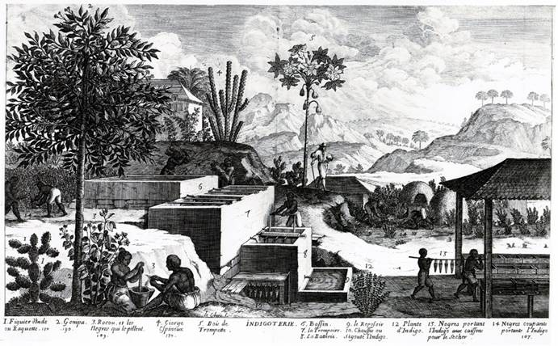
The Indigo Plant Farm
This print depicts and labels the key parts of the process of producing indigo. Slaves are working at different parts of the production process. In 1789, over 3,000 plantations in Saint Domingue (modern day Haiti) produced indigo.

South Carolina Indigo Exports, 1745-1775
Y ear | Pounds
1745 | 5,000
1748 | 134,118
1754 | 216,000
1757 | 894,500
1775 | 1,107,660
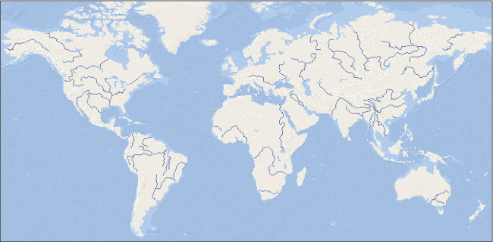
Source: Adapted from William James Hagy, This Happy Land: The Jews of Colonial and Antebellum Charleston (Tuscaloosa: University of Alabama Press), Table 26; and Marc Egnal, New World Economies: The Growth of the Thirteen Colonies and Early Canada (New York: Oxford UP, 1998), Figure 6.11.

a. Who is the producer of the indigo? What does the producer get for trading or selling the indigo?

b. Who is the mover of the indigo? What do movers get for transporting the goods? c. Who is the consumer? What do consumers give in order to get the goods they want?

d. How did the trade benefit the people who produced the indigo, transported it, and consumed or used it or the products made from it?

