Columbian Exchange: HOW MANY PEOPLE DIED?
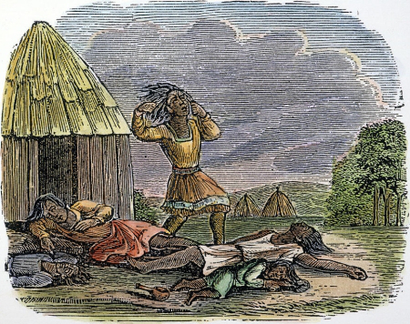
(Estimating the number of deaths due to imported diseases is difficult for two reasons. First, we have only rough estimates of the population of most of the Americas even after Europeans arrived and started counting people. Then, researchers use data on present-day epidemics to estimate what a likely death rate would have been for a population with no immunity to any of the diseases Europeans brought. A small inaccuracy in the estimated death rate can lead to very different estimates of population, and researchers argue about both numbers.) Adapted from LearnNC.org
The figure most often cited is that 90 to 95 percent of the native population of the Americas died between the time Columbus landed in the Caribbean and the end of the eighteenth century. That percentage is based largely on epidemiology — the study of how diseases spread in populations. But no one knows exactly how many people died, because no one knows exactly how many people were here in 1491, before Columbus arrived.
In 1910, James Mooney, an ethnographer at the Smithsonian Institution, made the first scholarly estimate of the indigenous population of the Americas. Mooney used old documents to estimate that in 1492, North America had 1.15 million inhabitants. Mooney was widely respected in his field, and for decades, other researchers accepted this figure. Then, in 1966, anthropologist Henry F. Dobyns used new research in epidemiology to estimate that 95 percent of the native population of the Americas died after European contact — 95 percent of an original population of 90 to 112 million people, more than the population of Europe at that time!
Based on further research, Dobyns later reduced his estimate to 18 million people. Other researchers estimate far fewer, as low as 1.8 million. Others have proposed numbers in between. But regardless of whether 1 million people died or 100 million, scholars agree that disease devastated native populations, cultures, and societies. To put those numbers in perspective, consider that 1.8 million people is the population of Charlotte, Raleigh, Greensboro, Durham, Winston-Salem and Fayetteville combined; 18 million is more than twice the current population of the state of North Carolina; and 100 million is a third of the population of the United States.
QUESTIONS
1) Why are estimates before 1492 so difficult to make?

2) How have estimates of the Native American population been made in the past?

3) What responsibility did Europeans bear regarding the 90-95% destruction of the Native Americans?

4) Why is the estimate of population of Native Americans important to many historians and many native peoples who survived European colonization?

