Thomas Hobbes on Absolutism
"[People] united in one person is called a Commonwealth [the state/country]…This is the generation of that mortal god [divine right king] to which we owe, under the immortal God, our peace and defense. For by this authority, given [to] him by every particular man in the Commonwealth [the state/country], he has the use of so much power and strength given to him that, by terror [alone], he [can] channel the will of every person, to peace at home, and mutual aid against their enemies abroad. And in him [this divine right king] consists the essence of the Commonwealth [state]; which, to define it, is one person, whose actions a great multitude [of people], by mutual agreement, have made themselves the author… he [the king] may use the strength and means of them all as he shall think beneficial for their peace and common defense."
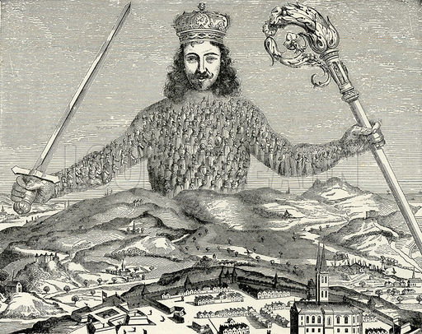

QUESTIONS
1) What type of government is Hobbes advocating for? How does it work?

2) What are the advantages of this kind of state?

3) Where does this leader derive his authority from?

