The Hellenistic World - After Alexander

Trade
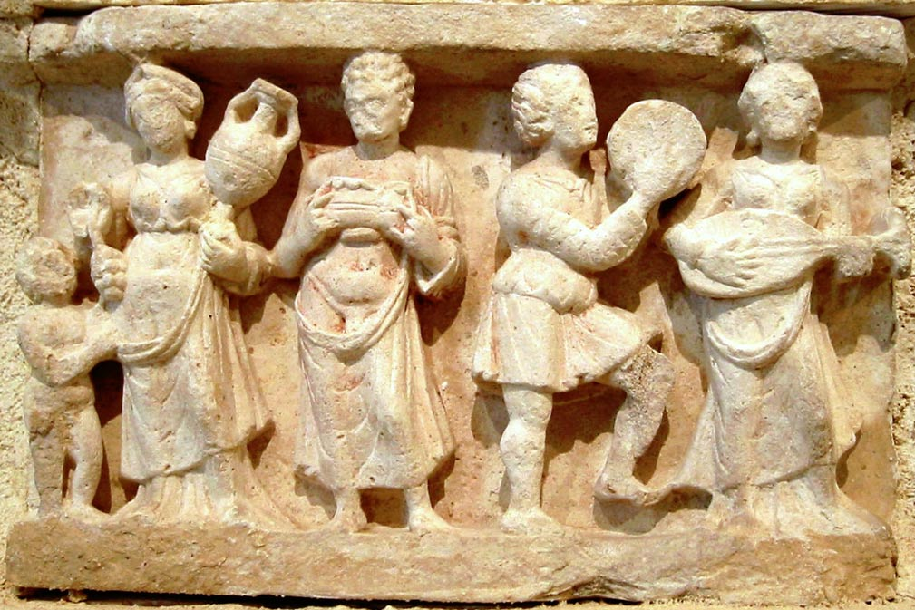
The campaigns of Alexander had opened gigantic areas to world trade and economic development. The conquering Greeks had aroused the sleeping masses of the east and profitable industries and agricultural enterprises sprung up everywhere. Because Alexander had started to mint the gold reserves of the Persian kings, huge amounts of money came into circulation. For centuries the Persian dynasts had safeguarded the treasures stored in their palaces. Alexander tried to spend them all within a matter of years.
As factors combined, Hellenism can be seen as the world's first major economic boom. The system of economics and trade that developed after Alexander's death would remain basically unchanged for over two thousand years, until the industrial revolution of the 19th century. When the Romans began to expand their empire around 200 BC they inherited a world of flourishing trade contacts for which Alexander had laid the foundations.

Cities
As world population was rapidly growing, the Hellenistic era saw the rise of new Greek cities everywhere - from cosmopolitan Alexandria in Egypt to the cultural melting pot of Taxila in present day Pakistan. The Seleucid dynasty, successors of Alexander in Asia, built numerous cities in the Middle East. Most Seleucid cities bore the names of their kings, like Seleucia and Antioch, or of their queens, like Apameia. Egyptian Alexandria, on the crossroads of trade routes and the principal city of Hellenism, had one million inhabitants. Seleucia, the first Seleucid capital, had half a million.
Hellenistic cities were centers of trade, science and arts, with huge gaps between the rich and the poor. While the cities offered splendor and luxury for the wealthy, large portions of the population lived in absolutely miserable conditions. Especially in Alexandria, riots were common.

Art
The arts florished in the Hellenistic world - especially painting, sculpture and architecture - although the emphasis was on quantity rather than quality. The harmonic principles of earlier Greek art were neglected. More works of art were produced than ever before, but few of them were masterpieces and 'bombast' ruled.

Science
Science blossomed during Hellenism. The metropolis of Alexandria hosted the largest library of Antiquity with over 70,000 books and half a million scrolls. In 235 BC Erasthostenes measured the circumference of the earth by comparing the length of shadows in Upper and Lower Egypt. His calculations predicted the equator should be about 47,000 kilometers long. (The correct answer, as we know now, is 40,000 kilometers.)
Technical progress was enormous. New machines and instruments were invented. But the greatest genius of the era was Archimedes, the 'Einstein' or the 'Newton' of Hellensim. This Greek mathematician and psysicist, living in Syracuse on Sicily and famous for the discovery of the rules of density, is considered the most important scientist of the ancient world.
Identify and explain 4 Changes in the Middle East brought about by Alexander the Great
1)
2)
3)
4)

