Han Emperor Liu Bang
By Benjamin Breen
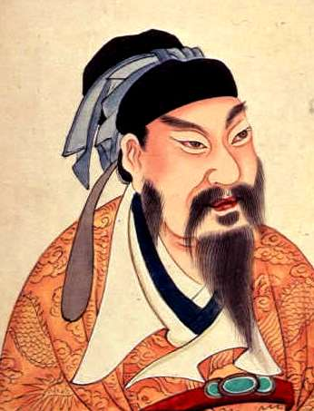
It is undeniable that some individuals do change the course of history through sheer force of will – not to mention a remarkable degree of luck. Such a person was Liu Bang, who rose from obscurity to be crowned emperor of China 2219 years ago on the 28th of February, 202 BCE.
As with many dynastic founders, it is difficult to separate the truth about Liu Bang—or the Emperor Gaozu of Han, as he came to be known—from the legendary tales about his life and character that proliferated in posthumous histories of his reign.
Today, what stands out about Liu Bang’s story is not only his immense importance as a founder of famous dynasty and shaper of Chinese culture, but also his humble origins: Liu Bang was born a peasant. Thus few details about his life before becoming emperor exist.

He was born in a small village in the present-day Jiangsu province on the eastern coast of China. Home to canals, fisherfolk and small-hold farmers.

In his late twenties, however, Liu improved his condition by passing the civil service exam—high marks on government tests were a powerful engine of upward mobility in China, then and today— and he became a minor provincial official. By this time, it would seem, his personal qualities were becoming apparent: Liu married well above his social station, to Lü Zhi, the daughter of a wealthy country gentleman.

By his forties, Liu seems to have become a popular local political figure, noted for his magnanimous nature. But he was not a particularly powerful man. There were thousands like him, local magistrates whose tax-collecting and governance allowed the first emperor of China, Qin Shi Huangdi, to sustain his rule.

The event that would change Liu’s life converged in a fascinating way with the vast mausoleum of terracotta soldiers for which Emperor Qin is most famed today. Liu was charged with escorting a group of prisoners to the mausoleum, where they would toil at its construction. By this time, the misrule of Qin’s ineffective son had resulted in widespread peasant revolts, and it seems Liu decided to take common cause with his own prisoners, becoming an outlaw and rebel himself.

The story of how Liu gained the throne is incredibly complex, and involves a series of double-dealings between the peasant leader and the man who was widely predicted to become the next emperor, the young nobleman and general Xiang Yu. Despite their vastly different upbringings, the two men had much in common: both scorned books, learning and historical precedent, and both were wildly ambitious. “Books are only useful in helping me remember my name,” Xiang had boasted as a youth. “Mastering swordsmanship allows me to face only one opponent, so it’s not worth learning. I want to learn how to defeat 10,000 enemies.” Liu appears to have shared this sentiment, and the two rebel leaders were initially friends and allies.

As emperor, Liu cannily played upon his identity as a farmer and common man, and became famed for his earthy and rustic ways. “Make it simple,” he was famously said to have ordered his chamberlain, when asked about the implementation of courtly etiquette. He lowered taxes on farmers and encouraged peaceful trade, but spent much of the rest of his life quashing rebellions in distant frontier regions to the north and west of the Han heartlands. By his death, the empire had expanded to become one of the largest in history up to that point.

To be sure, Liu was by no means a perfect ruler. Intrigues surrounding him and his numerous family members have been memorialized in a number of sordid stories, the worst of which involve the infighting between his consorts and children at court. (One particularly appalling, and perhaps apocryphal, account holds that Liu’s first wife amputated the limbs of his favorite mistress and forced her to wallow in a pigsty).
What is really important about Liu today, though, isn’t his character, his family or even the specifics of his reign. He was a world-historical figure, as Toynbee noted, and his larger importance stems from the enormous historical changes his reign set in motion. At its greatest extent, the Han empire pushed westward into the Turkic and Iranian western steppes of Asia, a world that we usually regard as separate from China. It was in this time that the Roman empire became aware of China, calling it ‘Seres,’ the land of silk (the Chinese called Rome ‘Da Qin,’ and seem to have regarded it as a sort of western mirror image of the Middle Kingdom). Lu Biang’s reign initiated the cultural connections and long-distance trade that brought about Silk Road and, at a more distant historical remove, our own contemporary era of globalization.

1) What were Liu Bang's origins? How did he improve his position in life?

2) How does Liu Bang's rise demonstrate Confucian principles?

