Greece Day 1-Introduction

AIM:

Homer-

Iliad and Odyssey

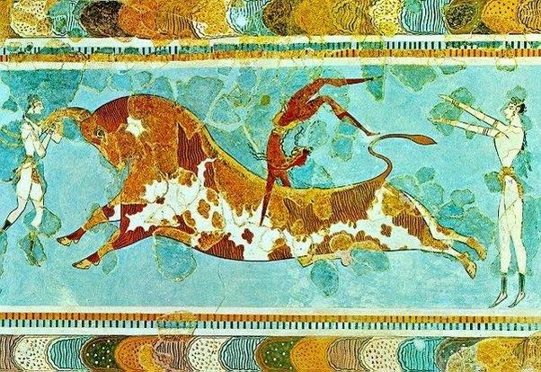

Minoans-

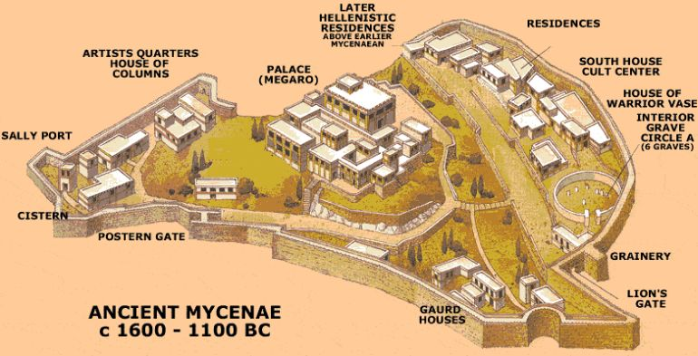
Mycenaeans-

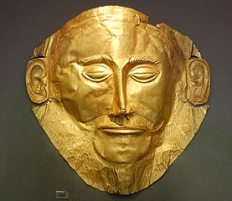
Greek "Dark Age"-

City-state-

