The Silk Road
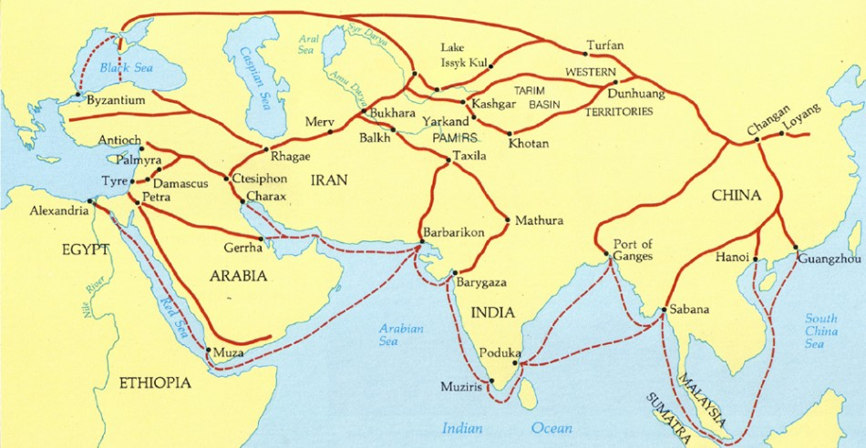
By John Major-adapted
The term Silk Road describes a network of trails and trading posts, oases and markets connecting East Asia to the Mediterranean. Along the way, branch routes led to different destinations from the main route, with one especially important branch leading to northwestern India and thus to other routes throughout the subcontinent. The Silk Road network is generally thought of as stretching from an eastern terminus at the ancient Chinese capital city of Chang’an (now Xi’an) to westward end-points at Byzantium (Constantinople), Antioch, Damascus, and other Middle Eastern cities. Beyond these end-points, other trade networks distributed Silk Road goods throughout the Mediterranean world and Europe, and throughout eastern Asia. Thus in thinking about the Silk Road, one must consider the whole of Eurasia as its geographical context. Trade along the Silk Road increased or decreased according to conditions in China, Byzantium, Persia, and other regions and countries along the way. There were always competing or alternative routes, by land and sea, to absorb long distance Eurasian trade when conditions along the Silk Road were unfavorable. For this reason, the geographical context of the Silk Road must be thought of in the broadest possible terms, including sea routes linking Japan and Southeast Asia to the continental trade routes.
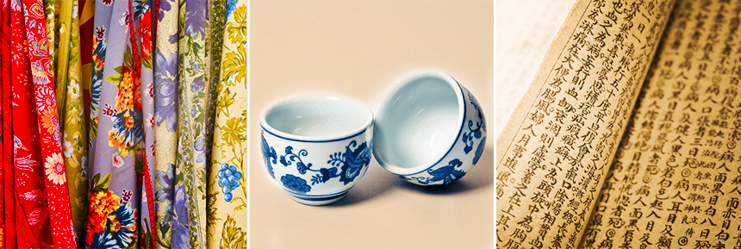
In dealing with the context of the Silk Road, it is important to remember that clearly defined and bounded countries did not exist before modern times. When we talk about the Silk Road passing through Afghanistan, it is with the understanding that there was in some sense no such place; the land existed, its population existed, but no country called Afghanistan existed before modern times. Throughout history, boundaries shift, peoples move from place to place, countries and kingdoms come into being and vanish, cities change their names.
China
Some trade routes in China historically fed into the Silk Road or distributed goods (such as silk, porcelain, and paper as shown in the image) from it. Other trade routes competed with the Silk Road, including maritime trade from southeastern ports across the South China Sea, and a route from the mountainous southwest down the Red River to Hanoi and Haiphong in what is now Vietnam. In China, people were likely to look variously inland, toward Central Asia, or seaward for trade.
QUESTIONS W
1) What regions did the Silk Road connect?

2) What goods were traded on the Silk Road? Which good do you think was the most valuable?

3) Is the Silk Road a road? Explain.

4) How do you think cultural diffusion occurred on the Silk Road (think in terms of merchants, goods, transactions, travelers, language, etc.)

