Student Handout 1.2—Origins of Fur
During the 1500s, Europeans began exploring the east coast of mainland North America. They traded items such as knives, hatchets, and beads to Native Americans for fur and meat. Indian trappers such as the Iroquois brought beaver furs from the interior to the St. Lawrence River and traded there for manufactured goods from Europe. Out of these early exchanges a formal fur trade was born in North America. It began in the area that is today modern Quebec. Because the best pelts were from areas that had severe winters, most trade was in Canada. Some trade, however, also developed along the Mississippi River and to the west in the Rocky Mountains.
Fur
Have you ever thought about where your favorite hat comes from? Was it made in one place? How did it get from where it was made to your favorite store? What kind of profit do hat makers get?
Introduction
The fur trade in North America began between the Iroquois and Europeans in the early 1500s. Within a few years, French, English, and Dutch fur traders were bartering with the Iroquois throughout the Mohawk Valley in order to compete to control the trade. Even though other furs were traded such as fox and mink, the beaver became the most valuable fur by far. Why? Beaver fur is soft, smooth, waterproof, easily shaped, and long-lasting. It also became the most fashionable type of felt hat in Europe from the 1600s until the 1830s. Beaver pelts were made into hats in Western Europe and Russia after a long and specialized process. Both rich and middle class Europeans were willing to pay a lot of money for beaver hats.
Over-hunting in Europe had created a real need for a new source of beaver fur, so the European discovery of the North American beaver was a big deal for traders. Whoever controlled the trade of fur in North America stood to profit immensely. The first Europeans to dominate the trade were French. Explorers such as Samuel de Champlain established trading posts in their territory called New France. Nations such as the Iroquois and Huron would trade fur pelts in order to get items of new interest to them, such as knives, pots, wool blankets, axes, and guns. Mirrors became one of the most essential trade items because men could use them to dress and paint themselves without the help of their female relatives. Indigenous men and women were both involved in the fur trade. The men captured the beavers, and the women tanned the hides and removed the rougher outer fur before trading them to the Europeans for manufactured goods.
Then in 1670, a major change occurred. The British founded the Hudson Bay Company. It soon controlled all the fur trade in the lands around the Hudson Bay. This is called having a monopoly. In order to trade with the various Indian nations, the Hudson Bay Company set up trading posts where the fur could be brought in exchange for money or goods. This arrangement worked well for a while, and merchants sent furs to London instead of Paris. British manufacturers made money selling their hats and other fur products back to indigenous and European consumers in North America. Generally throughout the 1770s, fur trade took place at the large trading posts established by European trading companies. Then in 1783, the North West Company was founded in order to compete with the Hudson Bay Company by looking for new sources of fur in the northern and western regions of Canada. This was the first joint stock company in Canada and possibly North America. Competition between the British and the French for control of the fur trade continued through the nineteenth century. Russian merchants, who trapped and traded sables and other fur-bearing animals in Siberia, also got into the North American game. They established a fur trading company in Alaska when it was a territory claimed by the Russian empire. In 1799 they founded the Russian-American Company.
a. Who is the producer of the fur? What does the producer get for trading or selling the fur?

b. Who is the mover of the fur? What do movers get for transporting the goods? c. Who is the consumer? What do consumers give in order to get the goods they want?

d. How did the fur trade benefit the people who produced the fur, transported it, and consumed it or used the products made from it?

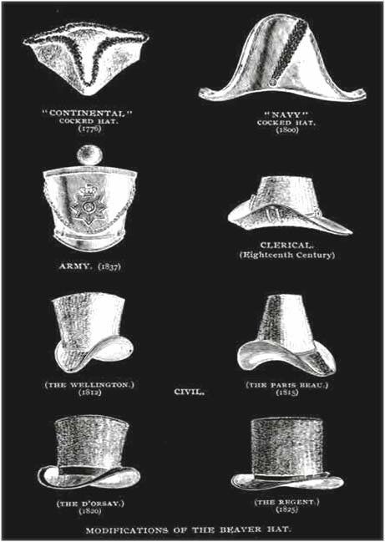

Student Handout 2.3
In 1722-1723, three French forts along the Great Lakes supplied the following goods in exchange for about 8,000 beaver pelts:
1605 sewing needles 632 catfish hooks 273 men's woolen shirts 336 women's woolen shirts 214 children's woolen shirts 217 butcher knives
2,109 other knives 243 pounds of red and yellow copper cauldrons 328 axes 59 guns 4,493 gun flints 3,640 pounds of shot and balls 6,463 pounds of flour
French exports to Europe
1620-1630 | About 30,000 beaver skins a year
1680s | About 140,000 beaver skins a year
1800 | About 200,000 beaver skins a year

