French Revolution Causes
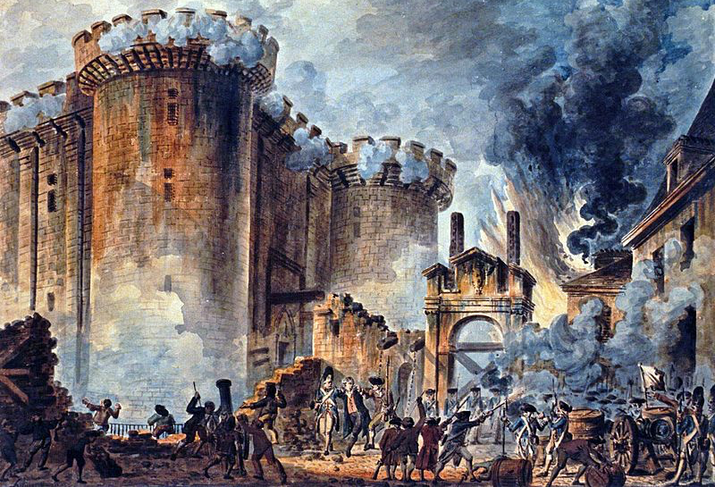

Growth of Middle Class

Young Generation

Literate Society

Military Losses and Financial Troubles

Estates General

1st Estate
2nd Estate
3rd Estate

